Clinical Learning Australia

Training Guide



quick reference guide for

cla administrators

Managing Term Descriptions

This quick reference guide describes how to manage Term Descriptions in Clinical Learning Australia (CLA). This guide will explain the process to follow to add Supervisors to Terms and manage other updates.

Table of Contents

1 What is a Term Description? 3

2 Where do I find Term Descriptions? 3

3 Who can edit Term Descriptions? 4

4 Editing term descriptions 5

4.1 Adding Supervisors to a Term Description 6

5 Exporting Term Information 8

6 Mapping Outcome Statements 9

7 Support 10

# What is a Term Description?

A term description describes the learning experiences and outcomes that a trainee will have the opportunity to participate in or demonstrate in a particular term. It also identifies the speciality, subspecialty and clinical exposure classifications for the term and the prevocational outcomes statement that a trainee will have the opportunity to demonstrate. Term Descriptions can also include details of CLA supervisor users for that term. Where supervisors are added to a Term Description as described below, these supervisors are automatically linked to any trainees assigned to that term when term allocations are created.

# Where do I find Term Descriptions?

**State Administrators and MEU Administrators** can view Term Descriptions via the Admin menu in CLA.

* Navigate to the ‘cog’ icon in the left-hand menu and click **Terms**



**Trainees, Supervisors and DCT/EDMS roles** will see Term Descriptions within each Trainee’s ePortfolio for each term that the Trainee is allocated to.

* Click into the Trainee’s ePortfolio for a particular term
* On the right-hand side under ‘Term Content’ click ‘View full term content’

Where a supervisor has been nominated as the ‘Term Supervisor’ for a particular term or trainee, this is also shown in this section.

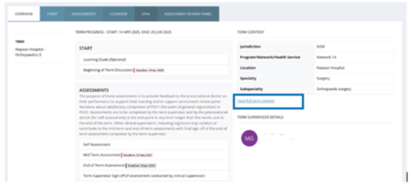

# Who can edit Term Descriptions?

Term Descriptions are ‘owned’ by an organisation in CLA. Only administrator users assigned to the owning organisation can edit Term Descriptions. Administrators can view the owning organisation in the Terms screen via Admin menu.

* Click on the ‘cog’ icon in the left-hand menu and click **Terms**

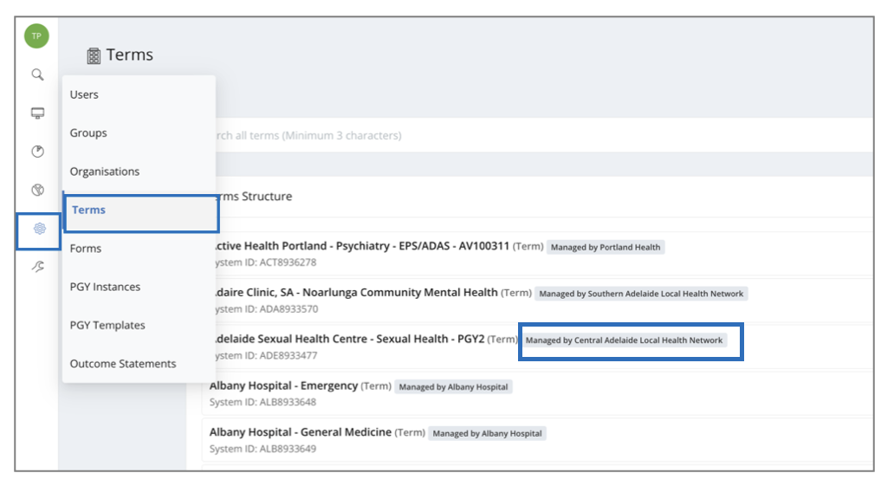

Beside the name of each term, you will see a ‘Managed by’ label. This identifies which organisation in CLA owns the term and is therefore able to edit a term.

# Editing term descriptions

To edit a Term Description, an administrator user from the owning organisation can:

* Search for your term(s) using the Search box at the top of the page.
* Click on the three dots to the right-hand side of the term you wish to edit
* Click **View/Edit**

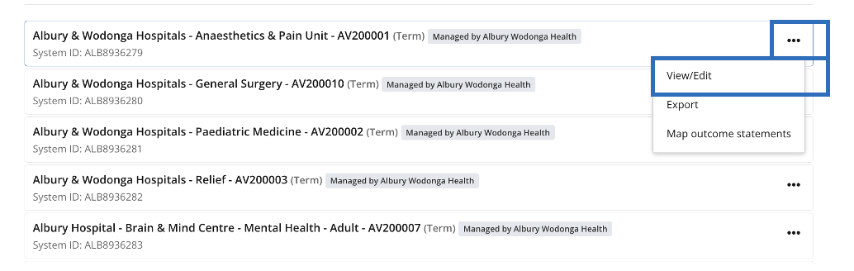

This will open the full Term Description and you will be able to edit the details within it.

Please follow the process for your state/territory for updating term descriptions. In some states/territories, changes are required to go through the relevant Prevocational Medical Council.

## Adding Supervisors to a Term Description

To add Supervisors to a Term Description:

* Click on the field at that top called ‘Term Supervisors / Clinical Supervisors’
* Type the name of the Supervisor you would like to add into the field and select the relevant user from those that appear below. **Note**: you can only find and add supervisors linked to your organisation. If you need to add a supervisor linked to another organisation, contact Nationwide Administrator to assist with this.

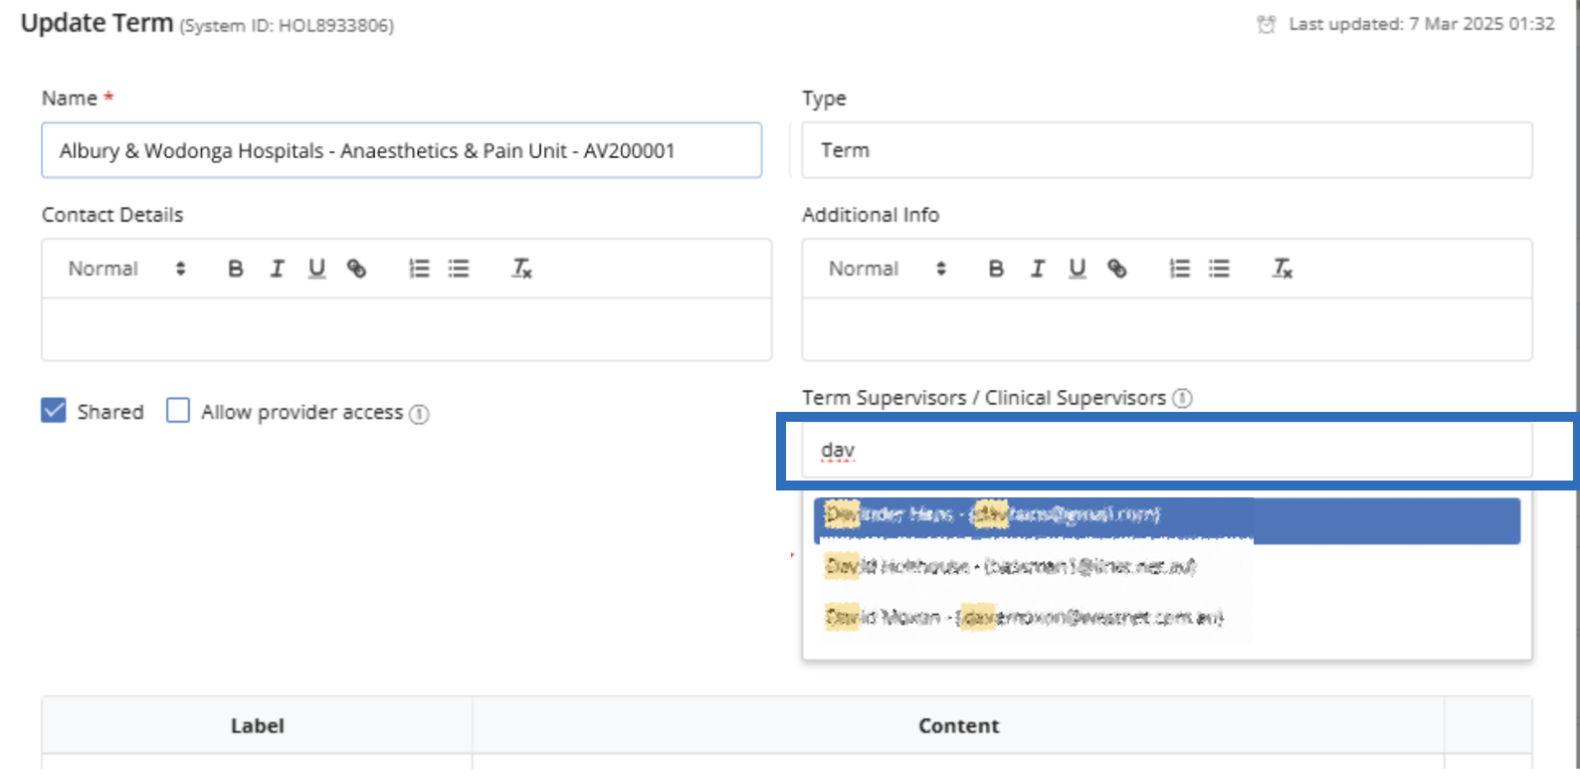

* You can add multiple supervisors in this way
* You can assign one supervisor as the ‘Term Supervisor’ and multiple as ‘Clinical Supervisors’
* If there are multiple individuals who can be Term Supervisors, it is recommended to add all supervisors as Clinical Supervisors on the Term Description and assign one of the supervisors as the Term Supervisor for individual trainees in Term Allocations (see the **Quick Reference Guide Creating and Managing Term Allocations**).

Where you have added supervisors to the Term Description as above, it is recommended to also add their details to the Term Supervisor text fields below as these are visible to Trainees. Ensure the supervisors listed in these text fields are accurate.

Once you have made all changes to the Term Description click **Update** at the bottom of the form.

Where supervisors are added to a Term Description, an overnight update needs to take place in CLA before these changes are available for new term allocations. Once the update takes place, any term allocations made after this will automatically link these supervisors to trainees allocated to their term and any other changes made to the Term Description will be visible trainees in their ePortfolios. Note that this currently only applies to new term allocations made after the Term Description is updated and changes to supervisors on the Term Description do not currently flow through to current or future term allocations already entered in the system.

It is possible to update existing term allocations to add the new supervisors that have been linked to the term. For more information, see the **Quick Reference Guide Creating and Managing Term Allocations**.

# Exporting Term Information

You can export information about each term:

* Search for your term(s) using the Search box at the top of the page.
* Click on the three dots to the right-hand side of the term
* Click ‘Export’

This will export an excel spreadsheet of the information for the relevant term.

You are able to export data all of the terms in CLA by clicking on the Export terms button above the list of terms.

Using filtering in Excel to filter and find your terms to see their contents. Note that supervisors linked to a term are not included in the individual or bulk term exports.

# Mapping Outcome Statements

You can map prevocational outcome statements to a Term Description. Where outcome statements have been mapped to a term they will automatically be ‘ticked’ as having been demonstrated by the Trainee in their End of Term Assessment for that term. The supervisor completing the End of Term Assessment can untick any outcome statements that have not been demonstrated and include others should they wish to.

* Click on the three dots to the right-hand side of the term
* Click ‘Map outcome statements’

* Select the most recent version of the Prevocational Outcome Statements available from the drop-down box on the left-hand side

* You will then be able to select the relevant Prevocational Outcome Statements to be mapped to the term.

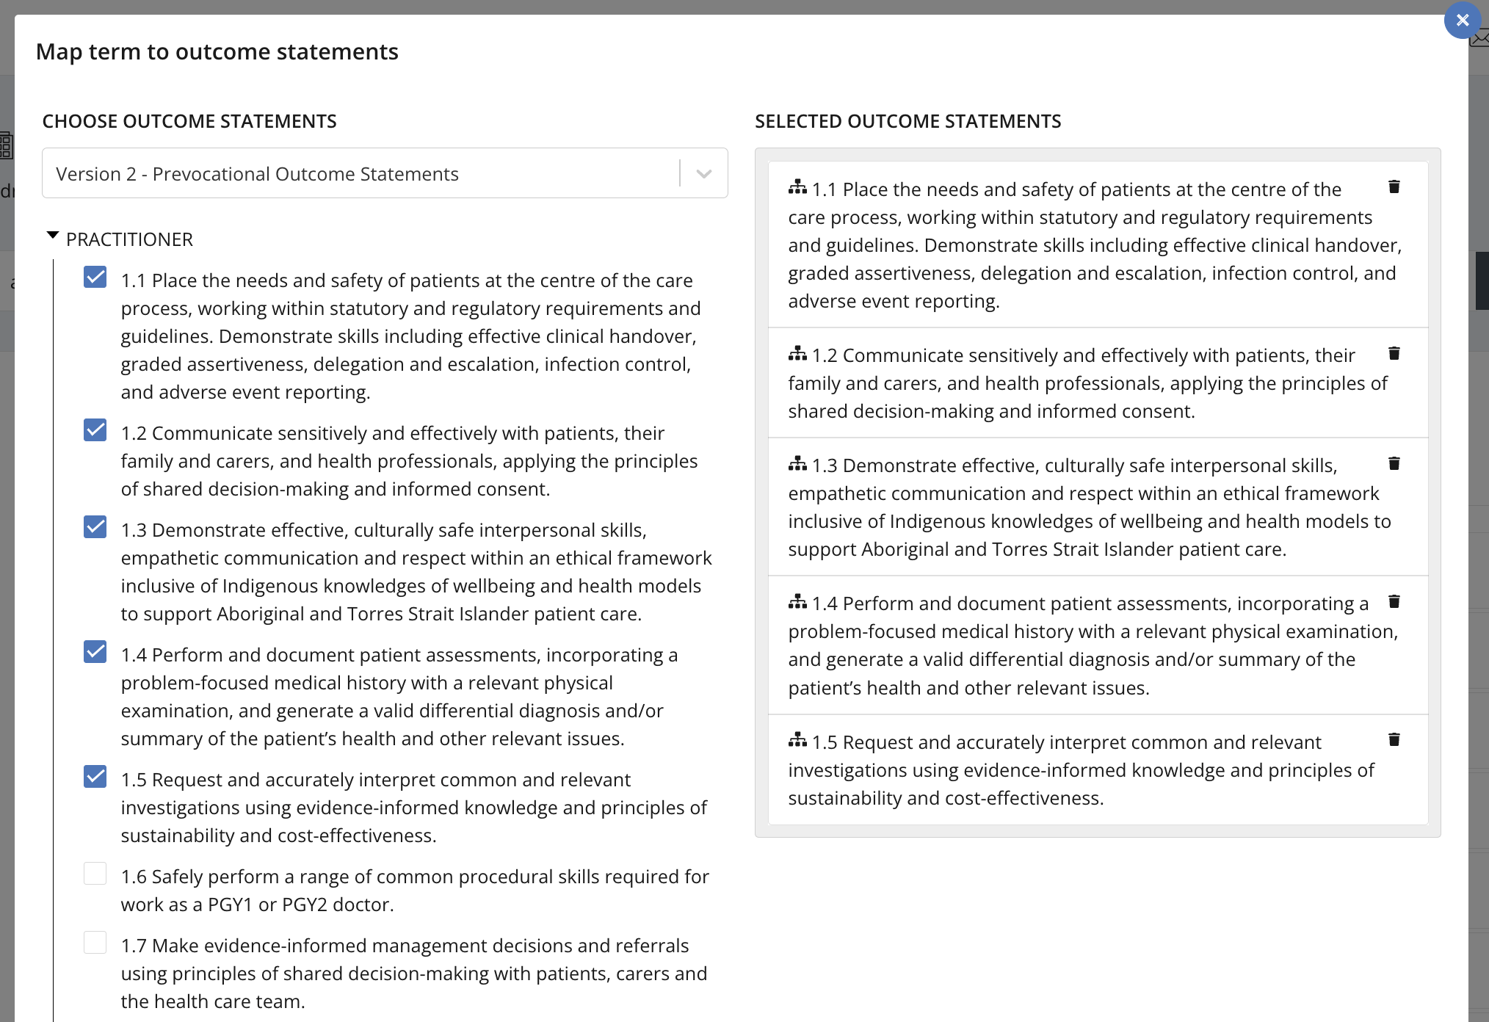

* When you have finished click the ‘X’ in the top right-hand side of the form and the outcome statements mapped to the term will be updated.
* Note: when you make changes to the mapped outcome statements, these do not apply to currently allocated terms, only new term allocations following the overnight CLA update.

# Support

If you require any support please contact the Nationwide Administrator. Contact details can be found on the [CLA website](https://www.digitalhealth.gov.au/healthcare-providers/initiatives-and-programs/workforce-capability/clinical-learning-australia).