Clinical Learning Australia

Training Guide



quick reference guide for

cla administrators

Creating terms and managing term allocations

This quick reference guide provides information on how to create term allocations in Clinical Learning Australia (CLA). This guide will explain the process to follow for allocating trainees to terms including linking term and clinical supervisors and how term allocations can be managed.

Table of Contents

1 Creating term allocations 3

1.1 Where to create term allocations 3

1.2 Creating term allocations manually in the system 4

1.3 Importing term allocations in bulk 9

2 Managing term allocations 23

2.1 Where to manage term allocations 23

2.2 Manual updates 24

2.3 Bulk updates 25

2.4 Managing term allocations for specific scenarios 27

3 Support 29

# Creating term allocations

Medical Education Unit / Administrator users of CLA can create term allocations either manually (one by one) in the system or in bulk via the **single term** or **multi-term** **allocations import spreadsheet**.

The following steps are done once a cohort group, trainee user accounts and PGY Instance are created.

You do not need to enter term allocations for the full clinical year at once if you do not yet have this information to hand and can add/upload on an ongoing basis if needed.

## Where to create term allocations

* Navigate to the ‘cog’ icon on the left-hand menu bar and click **PGY Instances**.
* Search for and click on the PGY Instance you want to add term allocations to.

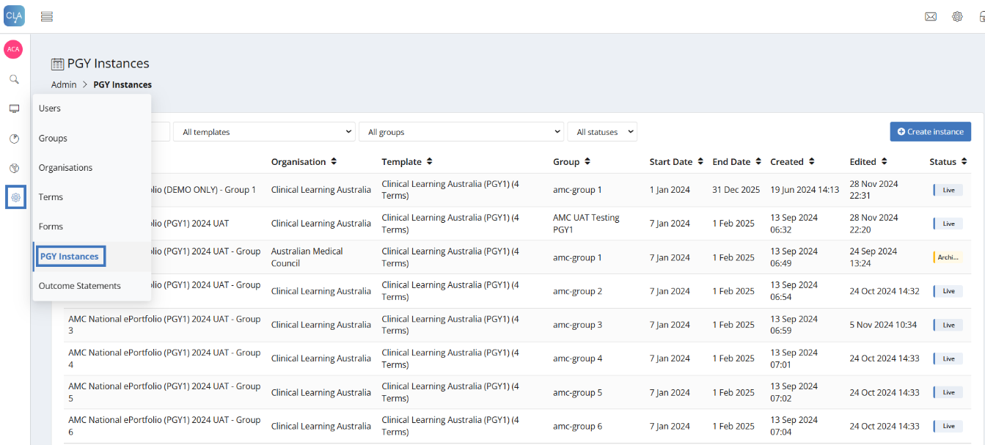

You will then be taken into that PGY Instance.

* Click on the PGY block to expand and display the terms.

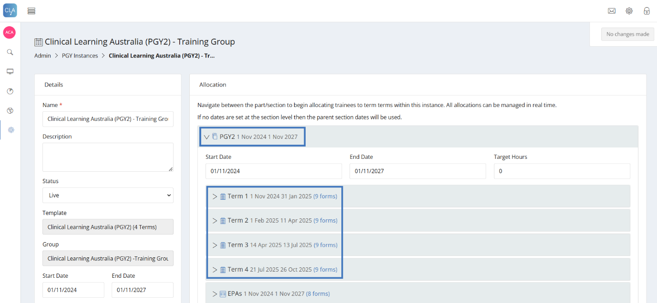

* Click on the relevant **Term** to expand and display the **term allocations** table.

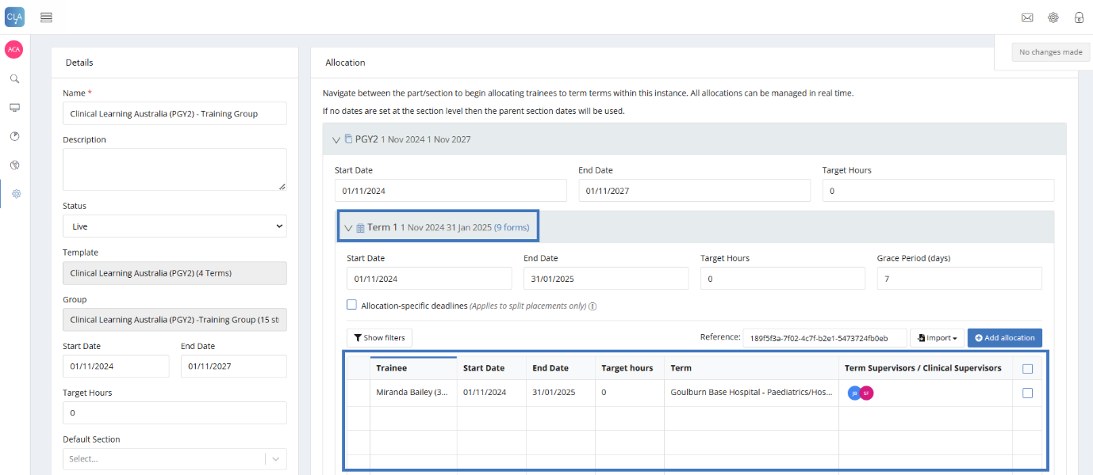

**Note:** If any term allocations have been created previously, these will be visible in the table. If no term allocations have been created previously, the table will be empty.

## Creating term allocations manually in the system

You can create term allocations manually (one by one) in the system or in bulk (see section 1.3 below).

To create term allocations manually:

* Navigate to the relevant term you wish to create term allocations for within the PGY Instance.
* Click on **Add allocation**.

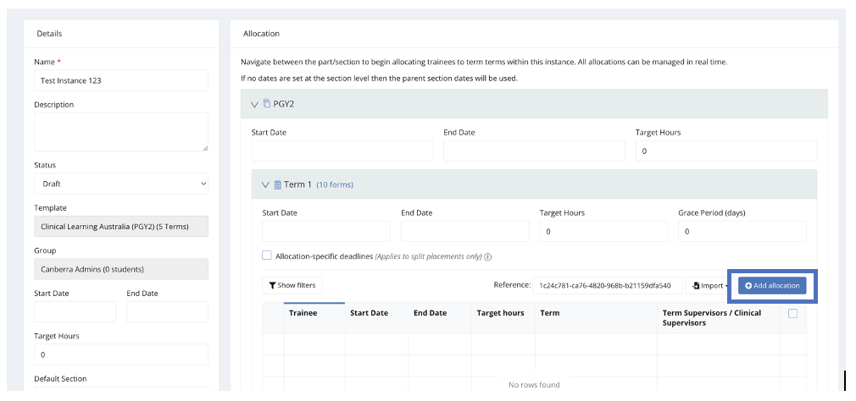

* This will open the ‘Create allocation’ window.

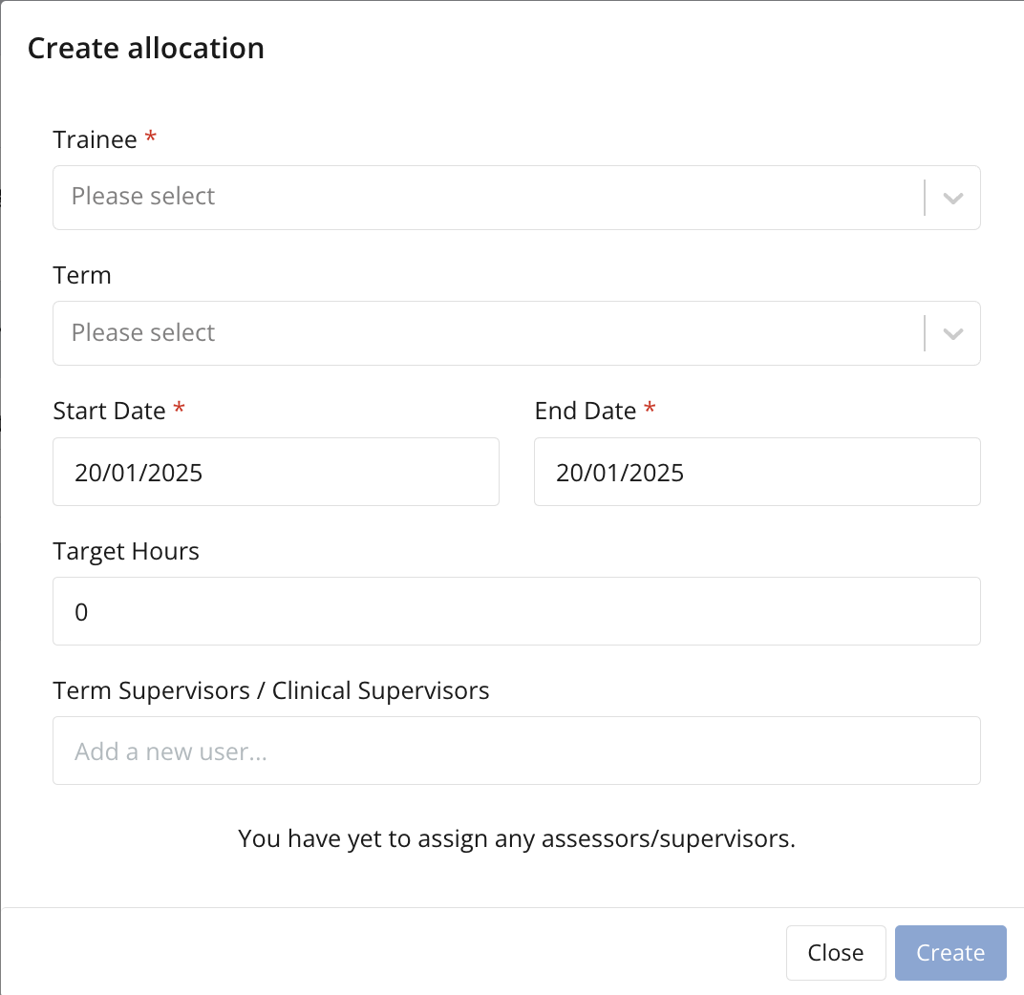

### Add trainee

* Select a trainee from the drop-down list or start to type the trainee’s name to find the trainee you want to add a term allocation for.
* **Note**: Only trainees that are assigned to the Group associated with this instance will be available to select from.

### Assign term allocation

* In the ‘Term’ field, start to type the name of the term you wish to allocate this trainee to.
* **Note**: All accredited terms have already been created in the system. If the term you wish to allocate the trainee to is not available, please contact CLA Support.

### Add start and end dates for this term allocation

* Enter the term start and end date for this term allocation.
* **Note:** The start and end date of a term allocation for a particular trainee can be different to the overall term start and end dates. In this way, trainees could have different start and end dates for term allocations within a term. Trainees can also be put on split terms where required, meaning two allocations are given for a term.
* See 2.4 Managing term allocations for more information about setting up split/blended terms or split contracts.
* **Note:** Leave the Target Hours field blank – this is not relevant for CLA.

### Link a trainee to a Term and Clinical Supervisor(s)

Next, you need to add the supervisor(s) to the trainee allocation and assign them a relationship of either Term Supervisor or Clinical Supervisor to link them to the trainee. This step gives the supervisor(s) access to the relevant trainee’s ePortfolio and they can complete assessments for them for the duration of the term.

If the terms you are allocating trainees to have had supervisors pre-linked in the Term Descriptions, these will automatically populate in the term allocations once you click ‘create’ and you do not need to follow these steps unless you want to add additional supervisors.

* Start typing the name of the supervisor in the Term Supervisors / Clinical Supervisors field.
* Select the relevant user to add them to the term allocation.
* Select the Term Supervisor or Clinical Supervisor relationship for each supervisor added, noting that the default is Clinical Supervisor.
* **Note**: There can be only **one user with the Term Supervisor role per trainee** per term allocation but there can be **multiple Clinical Supervisors**. Both Term and Clinical Supervisors can complete mid and end of term assessments as well as EPAs. Individuals assigned as the Term Supervisors are able to complete an additional sign off form to confirm they have read and agree with the end of term assessment where this has been completed by a Clinical Supervisor if necessary.
* If you have multiple individuals that may act as the Term Supervisors for a trainee, it is recommended that you enter all supervisors as Clinical Supervisors and review who has completed the End of Term assessments through the Detailed Response Report to determine if additional review and approval is required

* **Note**: Supervisors must already be set up as users in CLA to be added to a term allocation. Please see the **Creating and managing users** quick reference guide. Supervisors can be added or removed from a term allocation at any time (see section below on managing term allocations).
* **DCTs as Supervisors**:Where your DCT/DPETs also have a supervisor role in relation to some terms, e.g. Relief, to be able to allocate these, they must have a Main Role in CLA of ‘Supervisor (Term or Clinical)’. Change their role in Users to the Supervisor role and add them to your PGY cohort groups with the role of Director of Clinical Training. Please see the **Creating and managing users** and **Creating and managing groups** quick reference guides.
* Once you have completed all relevant fields, click **Create** to create the term allocation.
* The term allocation will then show in the term allocation table for the relevant term.

* Repeat the above steps for each trainee and for each term allocation you wish to assign them to if creating allocations manually.

## Importing term allocations in bulk

You can import term allocations for multiple trainees in bulk, either for each specific term one by one, or for multiple terms at once.

To import term allocations in bulk for a specific term, download and complete the ‘**allocations_import**’ **spreadsheet** from within the Term you wish to create allocations for in the relevant PGY Instance.

To import term allocations for multiple terms at once, download and complete the ‘**allocations_import_bulk**’ **spreadsheet** from above the PGY block in the PGY Instance.

Use to import multi-term allocations

Use to import single-term allocations

The key difference between the two methods is as follows:

**Importing term allocations for multiple trainees at once:** The multi-term allocation ‘bulk’ spreadsheet has a Reference column – here you put the reference code, which is a string of letters and numbers that uniquely identify each term in CLA, and this puts the trainee allocation into the correct term. To upload multiple terms, create trainee allocation rows using the reference codes for the specific terms that you want to upload trainee allocations to.

**Importing terms one by one:** To import allocations using the single term import spreadsheet, you need to prepare a separate spreadsheet for each term and upload these separately into each term.

### Downloading the term allocations import spreadsheets:

* Navigate to the ‘cog’ icon on the left-hand menu bar and click **PGY Instances**.
* Search for and click on the PGY Instance you want to add term allocations for.

**To download the multi-term allocations spreadsheet:**

* Click the **Import allocations** button on the top right-hand side of the instance page, above the PGY section.

* A pop-up box will appear with the option to **Download import template** – click on this.  
  A screenshot of a computer

  AI-generated content may be incorrect.
* This will download the ‘allocations_import_bulk’ spreadsheet that you can use to enter term allocations for multiple terms for all trainees.
* Save this spreadsheet to your preferred location.

**To download the single term allocation spreadsheet:**

In this method, a separate spreadsheet will need to be completed and uploaded for each term.

* Expand the PGY block on the right half of the screen.
* Navigate to and expand the term you want to import allocations for.
* Click on **Import** and then **Allocations** button

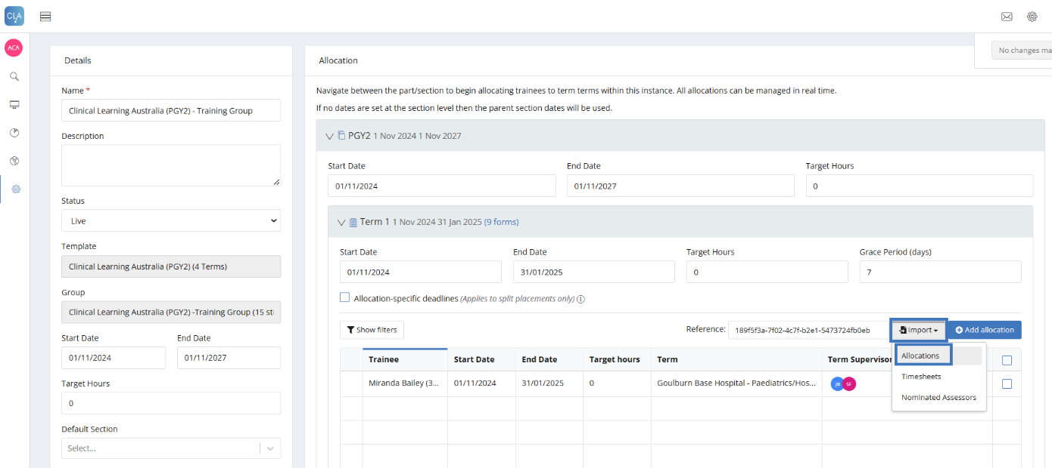

* A pop-up box will appear with the option to **Download import template** – click on this.

* This will download the ‘allocations_import’ spreadsheet that you can use to enter term allocations for all trainees for a single term.
* Save this spreadsheet to your preferred location.

### Completing the Term Allocations Spreadsheet

Complete the below fields in the spreadsheet, noting that the column A, Reference, is only included in the ‘allocations_import_bulk’ spreadsheet used to upload allocations for multiple terms.

|  |  |  |
| --- | --- | --- |
| Column | Description | Field Type |
| **Reference\*** | * This Reference column is only relevant if you are completing the multi-term ‘allocations_import_bulk’ spreadsheet. * The Reference column is where you put the Term Reference code and this is how the system knows which term (Term1, Term 2, Term3, etc…) the allocation on that row belongs to. * This reference is a string of letters and numbers that is found within each of the term blocks of the PGY instance. A close-up of a phone number    AI-generated content may be incorrect. * Click on the PGY block at the top right of the PGY Instance window to reveal all the term blocks. * Click into each of the term blocks within the PGY Instance that you wish to add term allocations to. * Within each block, you will see a string of letters and numbers under the ‘reference’ part of the term.   A screenshot of a computer  AI-generated content may be incorrect.   * This is the reference that needs to go into this column of the spreadsheet. * **Note**: The reference code will be different for every term and between PGY Instances. Reference codes are not reused in CLA. * **Caution:** When entering reference codes into your spreadsheet, be careful to not enter the reference in the first row and drag this down in Excel as this will change the numbering of the code and will cause errors when you attempt to upload the file. Copy and paste this reference into each row. | **Mandatory** |
| **StudentID**\* | * This is the Trainee’s Ahpra number or email address associated with their account. * You can find the Ahpra number and/or email by navigating the relevant user in the Users section of the administrator panel and searching for the relevant Trainee’s user profile. | **Mandatory** |
| **Provider SystemID or Short Code** * | * This ID links a Trainee to a specific term. * The Term Name or System ID reference for a Term can be used in this field. * Note that where you use the Term Name, it must be exactly as stored in CLA. * If using the Term System ID, navigate to the ‘cog’ icon on the administrator side menu bar and click **‘Terms’**. Find the term that you want to link the trainee to. * Below the heading of each term is a ‘System ID’. Copy the System ID reference and enter this into the ‘Provider SystemID or Short Code’ column in the upload spreadsheet (see screen shot below).        * **Note**: If you get a ‘No provider found’ error for a term when uploading using the term name, change this term identifier to the System ID. | **Mandatory** |
| **StartDate**\* | * This is the start date of the term. * For multi-term allocations, change the start and end dates for each term to reflect the start and end date for each specific trainee * **Note:** The start and end date of a term allocation for a particular trainee can be different to the overall term start and end date. In this way, trainees could have different start and end dates for term allocations within a Term. | **Mandatory** |
| **EndDate**\* | * This is the end date of the term. | **Mandatory** |
| **TargetHours** | * This field isn’t relevant for Clinical Learning Australia. Please leave blank or enter a 0. | Not used |
| **AssessorEmail1** | * This is where Supervisors can be linked to trainees. * Enter the Supervisor’s email address that is linked to their account in CLA. * **Note**: Supervisors must have been created as users in CLA before you can link them to trainees via the term allocations import process. If supervisors with matching emails do not exist in CLA at the time of importing, you will get an error message for each supervisor that does not already exist and you will need to resolve each error (i.e. find their email used in CLA or create an account if they don’t exist) before being able to upload the spreadsheet. * **Note**: If you want to add more than one Supervisor during the allocation process, you can add additional columns at the end of the spreadsheet noting Assessor Email2/Relationship2 and so on depending how many you need to add for a Trainee (see example below). Please ensure you follow the same naming convention and order as below for any additional columns you add.   A white grid with black text  AI-generated content may be incorrect.  **\*** It is possible to link supervisors to Term Descriptions from May 2025. Where supervisors have been linked, you do not need to enter supervisors in the import spreadsheet – these supervisors will automatically populate in the individual trainee term allocations once imported. | Optional |
| **Assessor**  **Relationship1** | * Enter the Supervisor’s relationship to the Trainee – this should be **Term Supervisor** or **Clinical Supervisor**. * If you want to assign a Term Supervisor relationship, enter **Term Supervisor** in the Assessor Relationship field. Leaving the Assessor Relationship blank will automatically assign them as a Clinical Supervisor. * **Note**: A Trainee can only have **one** Term Supervisor linked to them per term. The Term Supervisor can be replaced at any point if required * **Note**: A Trainee can have **multiple** Clinical Supervisors. Add additional columns for additional Clinical Supervisors as above.   Where Supervisors have been linked to a Term Description, the relationship as per the Term Description will automatically populate in the term allocation. This can be adjusted if a different supervisor is taking the Term Supervisor designation in relation to trainees. | Optional |

Example of a completed multi-term allocation spreadsheet for Terms 1 – 4 for a single trainee.

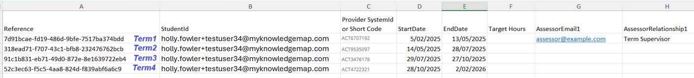

**Reminder:** The main difference in the multi-term spreadsheet is Column A ‘Reference’.

This reference is a string of letters and numbers. It is located within each term block (see below).

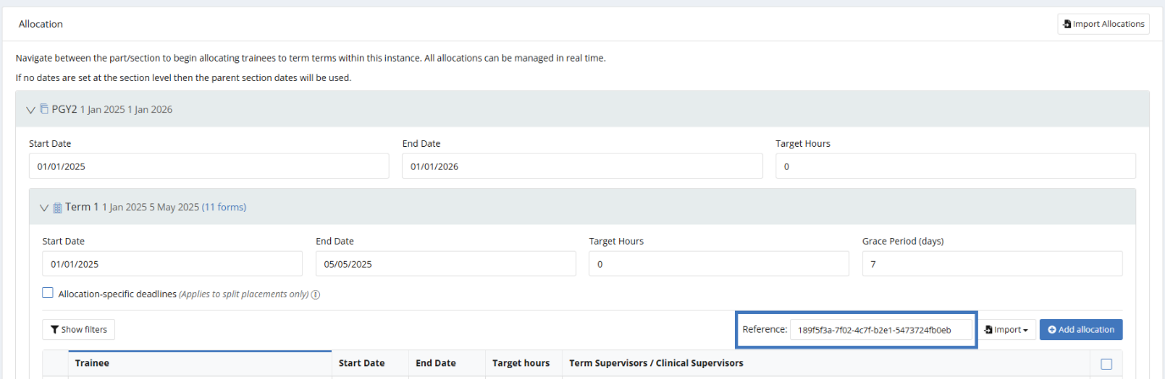

Ensure you highlight the full reference string, copy and paste into Column A of the multi-term spreadsheet.

Each term block has its own unique reference string.

Example of a completed single term allocation spreadsheet for three trainees for one term.



### Uploading the Term Allocation Spreadsheet

* Once you have completed the term allocation spreadsheet, save it to your desktop or another local file location.
* Navigate back to the PGY Instance.

To upload the multi-term ‘allocations_import_bulk’ spreadsheet:

* Click on **Import allocations** locatedat thetop right-hand side of the PGY Instance page.

* Click the **Drop file to upload** icon to select the file you created with the multi-term allocations and then **Upload** to upload the file.

* The screen will display the size and name of the file you are importing. Click **Import**.A screenshot of a computer

  AI-generated content may be incorrect.
* If there are no issues with the data, you will see a notification that the data has been successfully imported. Click **Done**.

* Once the file has been uploaded successfully, a message will appear and the term allocations will appear within each of the term allocation tables under each term block.

**To upload the single term ‘allocations import’ spreadsheet:**

* Expand the Term section for the term you want to import allocations for.
* Above the term allocation table click **Import -> Allocations**.

* Click on the **Drop file to upload** icon to select the file you created with the term allocations and then **Upload** to upload the file.A screenshot of a computer

  Description automatically generated
* The screen will display the size and name of the file you are importing. Click **Import**.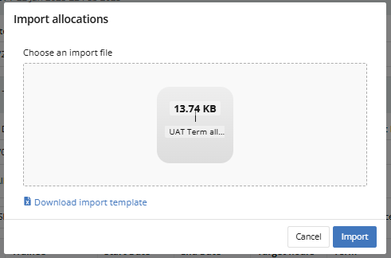
* If there are no issues with the data, you will see a notification that the data has been successfully imported. Click **Done**.

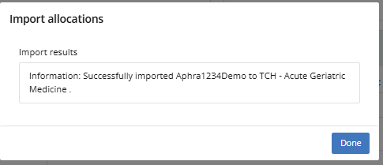

* Once you file has been successfully uploaded, the relevant term allocations will be visible in the table within the single term.

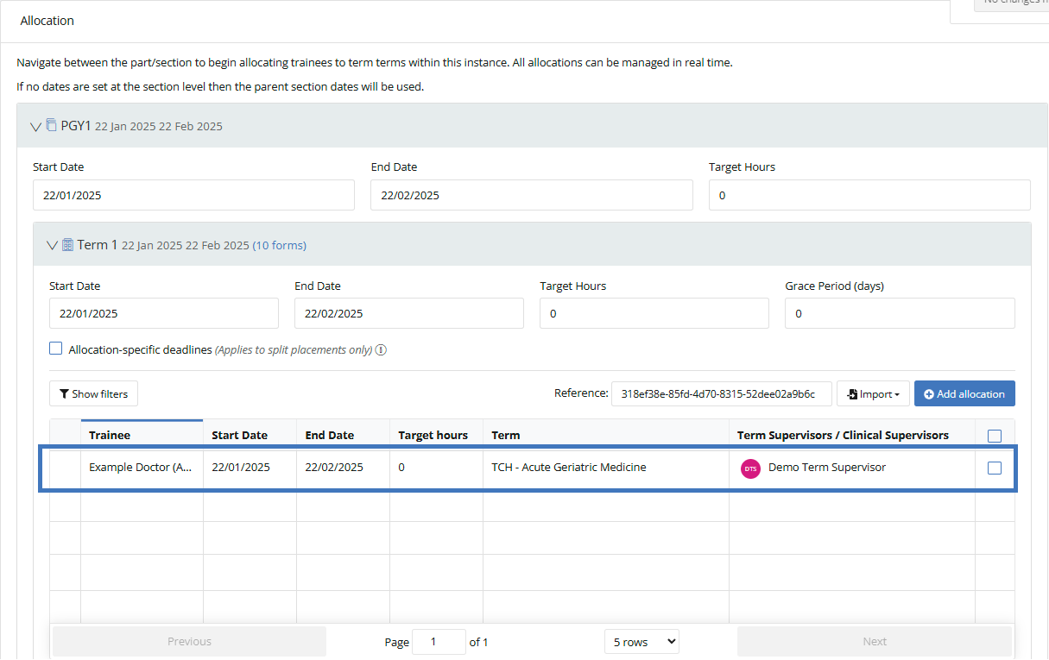

### Data validation

Regardless of whether you import the single or multi-term allocation spreadsheet, the data in your spreadsheet undergoes a validation process as part of the data upload process. If there are any errors with the data being uploaded these will be flagged on the screen for review and correction. Issues with data include:

* invalid Term Reference codes
* incorrect Ahpra number or email address for a Trainee
* invalid Term names or System IDs (‘No provider found’ error)
* a supervisor email does not exist in CLA yet (‘Could not find user’ error)
* multiple supervisors with the Term Supervisor role for a trainee allocation

Review your term allocation import spreadsheet, make necessary corrections, save the latest version and try to upload again. Some errors will allow the import for other trainees to go ahead. For example, a **No provider found** error for one term/trainee will allow the rest of the import to proceed and allocations to be created.

Take note of, or screenshots, of the red errors where the rest of the import rows display as ‘Successfully Imported’, resolve these errors and redo the import for the trainees that had an error or manual allocation.

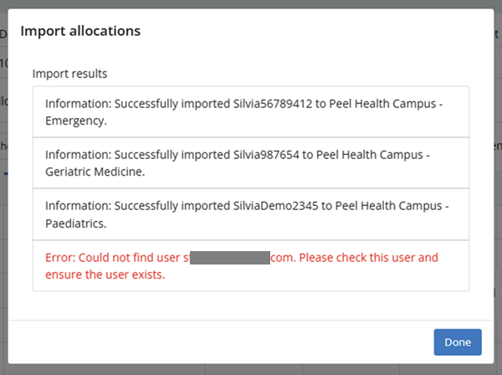

# Managing term allocations

## Where to manage term allocations

* Term allocations can be updated as and when needed by administrator users with relevant permissions.
* To manage term allocations, navigate to the ‘cog’ icon on the left-hand menu bar and click **PGY Instances**.
* Search for and click on the PGY Instance you want to manage term allocations for.

* You will then be taken into that PGY Instance.

* Click on the PGY block to expand and display the terms.

* Click on the relevant **Term** to expand and display the allocations table.

* Any updates that need to be made to a term allocation can be done either manually (one by one) by clicking on the term allocation to be changed or in bulk.

## Manual updates

* Click on the Trainee / Term Allocation you wish to make changes to.
* A pop-up box will appear with the current information for that Trainee’s term.

* You can then make any required changes to that Trainee’s allocation by selecting any of the fields available.
  + **Term** – Clicking into this field will allow you to type and search for the term you may want to update this Trainee to.
  + **Start/End Date** – Clicking into this field will pop up a calendar to allow you to select a start/end date you may need to amend.  
    **Note:** These date fields can also have the dates typed into them.
  + **Term Supervisors / Clinical Supervisors** – Clicking into this field will allow you to type and search for Term Supervisors and Clinical Supervisors that you may want to add to this Trainee’s term. After you select the Supervisor, select their relationship relevant to that Trainee.
  + You can edit existing Term Supervisors and Clinical Supervisors that are attached by changing the relationship they have to the trainee/allocation by clicking the dropdown that notes their role and updating it to be something else. Or you can delete existing Term Supervisors and Clinical Supervisors by clicking the bin icon to the right of the role dropdown.
  + **Nominated Assessors** - Ignore this field. This is not being used by CLA.

## Bulk updates

**Note:** Bulk actions make modifying term allocations simpler when you’re making the same change to more than one Trainee.

* Click on the boxes to the right of Trainee’s term allocations that you wish to make changes to.

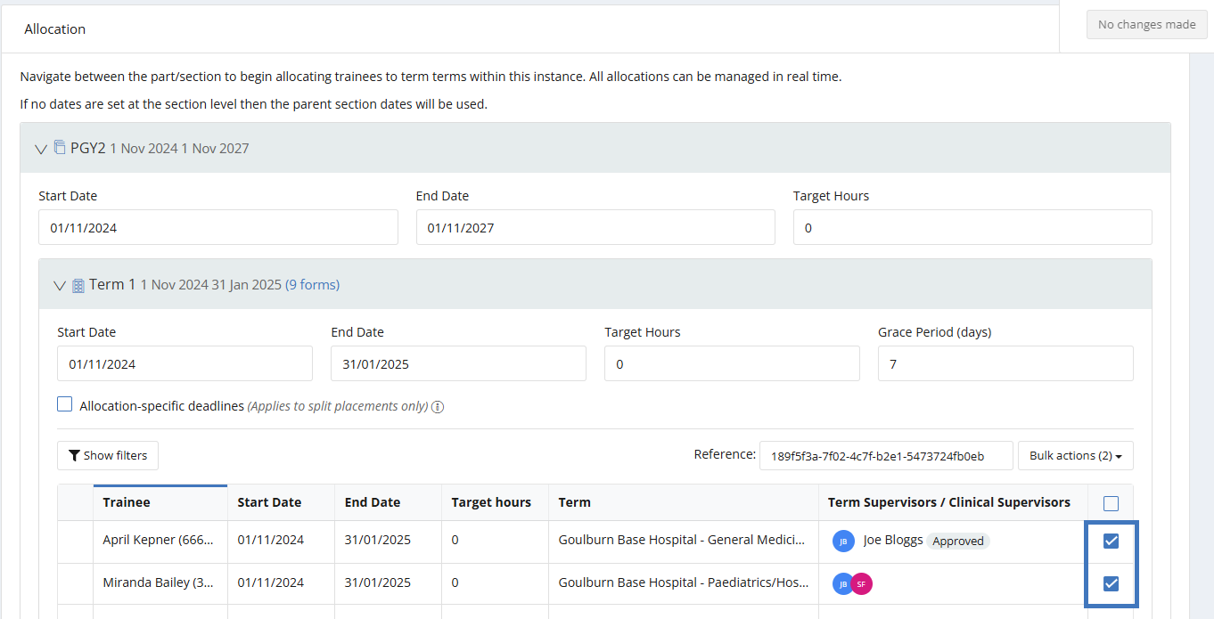

* Click on the **Bulk actions** button above.

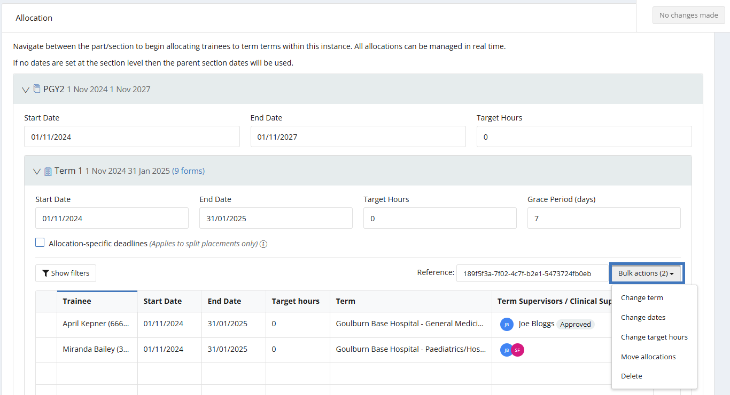

This will display a list of options that you can perform with the bulk actions.

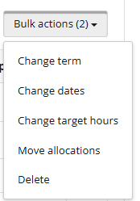

* **Change term** – This will allow you to type and search for the term you may want to update the selected Trainees to.
* **Change dates** – This will allow you to update the start and end dates for the terms for those selected Trainees.
* **Change target hours** – This field can be ignored. This is not being used by CLA.
* **Move allocations** – This would only be used if you happen to create term allocations in an incorrect term and you need to move them to the correct term.
* **Delete** – This will allow you to delete the term allocations for those selected Trainees.

### Bulk updating Supervisors

You can update supervisors already existing for a trainee’s term allocation. If you’re needing to add new supervisors to many trainees within a cohort group, you can use either of the bulk import spreadsheet processes noted in section 1.3. Ensure that the trainee’s term and start and end dates are the same in the import spreadsheet as those in CLA and the import will not create a new or split term - it will add supervisors only.

If you’re needing to remove or update the relationship of a supervisor to a trainee, you will need to go into the relevant term, locate the trainee’s term allocation, click the trainees name, and update the relevant information.

## Managing term allocations for specific scenarios

### Split terms:

CLA can accommodate situations where a PGY doctor has multiple allocations within a single term. This includes situations where they have one allocation for part of the term and another for the remainder (e.g. ED for 5 weeks and Gen Med for 5 weeks).

Term allocation display of a split term:

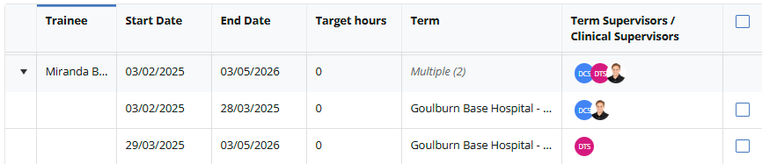

Include the multiple allocations to the Term Allocation Upload spreadsheet with the respective start and end dates or manually add the allocations using the **Add Allocations** function.

**Note:** If bulk uploading more than one term allocation for a Trainee, you will need to create a new line for the same Trainee for the other term allocations they may require. See example below. 

### Split contracts:

Where a Trainee works across two organisations during a clinical year, there are two scenarios that can take place.

* If the trainee continues to be 'employed' by Health Site A but rotates to Health Site B on secondment for a specific term, then Site A continues to maintain 'ownership' of the trainee and will have access to their record across all sites that they are assigned to. Other sites that they rotate to will only have access to the trainee’s record for the duration that the trainee is 'seconded' to or working within their term.
  + Add this trainee to your term allocations as usual for all terms and allocate the trainee to Site B for the required term.
* If the trainee’s employment / contract transfers from one site to another, it would be necessary to transfer them to the new site's organisation within CLA (i.e. change the Organisation to which they are attached in the Users profiles – see the **Creating and managing users quick reference guide**) so that the new site becomes their primary 'owning' organisation. If the trainee is moving to a new organisation within the same state/territory, then a state administrator user with relevant permissions across both sites can manage the change in 'ownership'. If moving interstate, then this change needs to be made by the Nationwide System Administrator, i.e. contact CLA Support. You will need to provide local DMS/EDMS approval at the new site for the trainee’s account to be transferred to the new organisation.
* If you have a trainee on split contracts:
  + Site A: Allocate the trainee to the terms for your organisation as per usual.
  + Statewide or Nationwide Administrator (must be notified by the sites): When the trainee transfers Site B, update the PGY doctor’s Organisation in Users to the new site.
  + Site B: Add the trainee to the relevant cohort Group and assign the trainee Term Allocations for their site in PGY Instance.
  + **Note:** The trainee’s record will transfer with them to the new site and users with relevant permissions (administrator users, DCTs etc.) in the new site will be able to view prior assessments for that trainee even where these have been completed in a previous site.

# Support

If you require any support, please contact the Nationwide Administrator. Contact details can be found on the [CLA website](https://www.digitalhealth.gov.au/healthcare-providers/initiatives-and-programs/workforce-capability/clinical-learning-australia).