Clinical Learning Australia
Training Guide



quick reference guide
Managing guest assessors in clinical learning australia

This Quick Reference Guide provides an overview of how the Guest Assessor role works in Clinical Learning Australia (CLA). It explains how to identify and manage Guest Assessor accounts in CLA.

Contents
1 What is the Guest Assessor role? 3
2 How does the Guest Assessor workflow work? 3
3 Viewing and managing Guest Assessors 4
4 What happens after a Guest Assessor is approved in CLA? 9
5 Support 9

What is the Guest Assessor role?
The Guest Assessor role is automatically assigned to anyone who undertakes an assessment for a prevocational doctor that does not have an existing account with a matching email address in Clinical Learning Australia (CLA).
A Guest Assessor account is created in the following circumstances:
- An assessment, such as an EPA or Mid Term Assessment, is completed in the prevocational (PGY) doctor’s account and the name and email address of the relevant assessor are manually entered into the assessment form.
- The prevocational doctor (or another CLA user) emails an assessment form to an individual to complete, using either the ‘Email’ function to send a blank form or ‘Email for Later’ function to send a partially completed form, entering in the assessing individual’s name and email address into the required fields.

How does the Guest Assessor workflow work?


1. An individual that does not have an existing CLA account with a matching email completes an assessment form for a PGY doctor.  This is done in two ways:  a) within the PGY doctor’s CLA account  b) the assessor is emailed a link by a PGY doctor to complete |  | 2. The response is submitted but flagged as having been completed by an unknown / unapproved user in CLA.  CLA creates a user account for the unknown user with the main role of Guest Assessor and a status of ‘Unapproved’ – this role does not have access to any functions in CLA. |  | 3. An email is sent to all MEU Admin and MEO users linked to the organisation that owns the term description for the term which the assessment is being completed.  The email highlights that an unapproved user in CLA has completed an assessment for a PGY doctor and that this ‘Guest Assessor’ account requires review/approval. This email is only sent the first time this guest assessor completes a form. |  | 4. An MEU Admin user reviews the unapproved user and verifies the user account by changing the Status to Approved.  The MEU Admin can change the role of the user from Guest Assessor to Supervisor (Term or Clinical) if appropriate.

Viewing and managing Guest Assessors
When a Guest assessor completes an Assessment form for a prevocational doctor, an email is automatically sent to Administrators at the organisation that the term is owned by notifying them that an assessment has been completed by an unknown assessor. This email notification is only sent the first time this email is used. CLA does not send any more notification emails for additional forms completed.
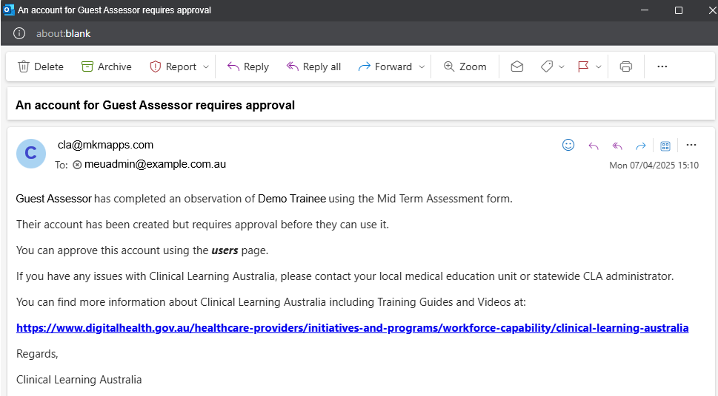
CLA also creates a new account for this Guest Assessor in the Users screen. The role applied to this account is Guest Assessor and the Status of the user defaults to ‘Unapproved’.
The Guest Assessor role has no privileges in CLA. Users with this role may be able to activate CLA accounts and login, but they do not have access to any information in CLA, including forms they have completed and trainees they are linked to.
Additionally, CLA adds the Guest Assessor to the Trainee’s term allocation for the term the form was completed for as a Clinical Supervisor.
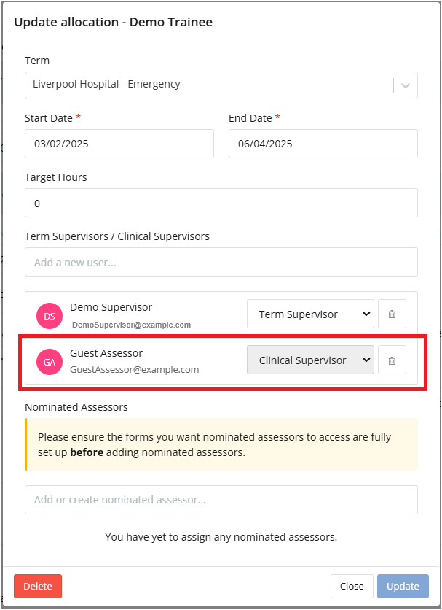
To find Unapproved Guest Assessors for your organisation
- Navigate to the ‘cog’ icon on the left-hand menu bar and click ‘Users’
- Click the 'Add Filter’ button
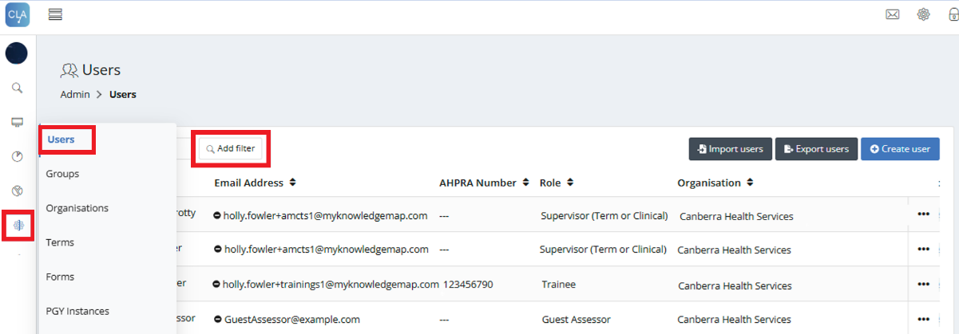
- In the dropdown box that appears, select Role.
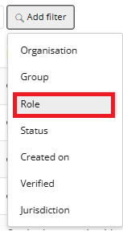

- In the Role filter, select Guest Assessor.
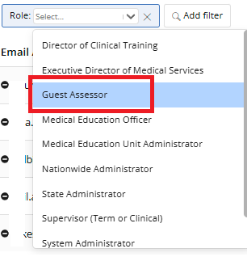

- This will display all users with the Guest Assessor role that have been created at your organisation level and those organisations below your organisation’s level in the hierarchy.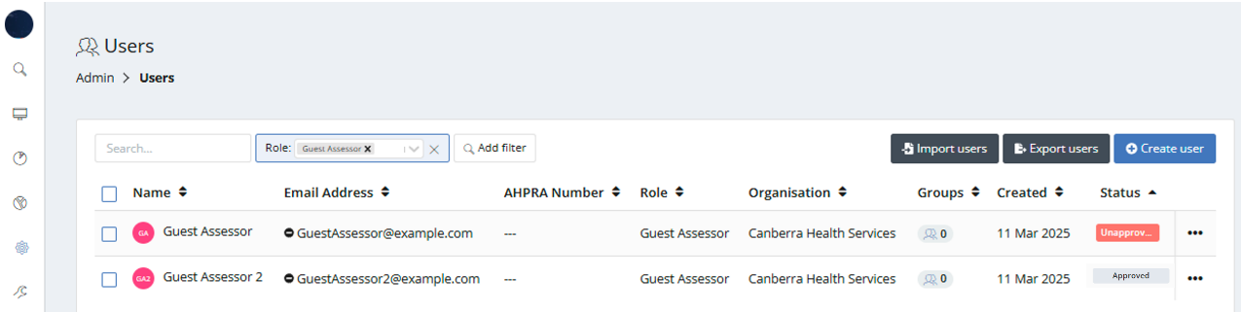
- Click the 'Add Filter’ button again and select Status.
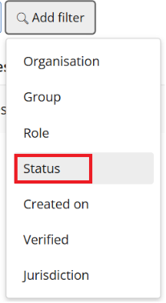
- Select the Status of Unapproved.
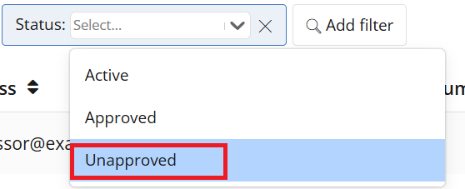
- This will display all the Guest Assessors for your organisation and below that have a status of Unapproved.
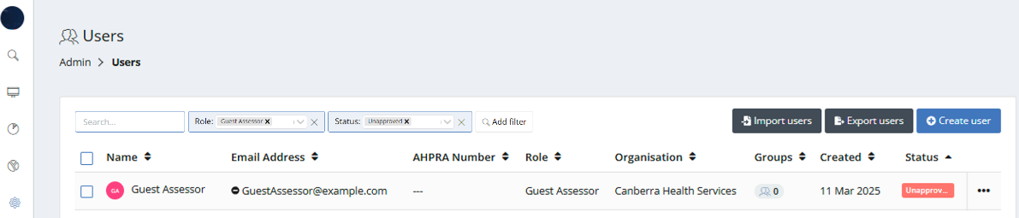

- Review the list of Unapproved Guest Assessors.
- For assessors that are valid for your site, click the three dots to the right of the user’s row and select Edit user.
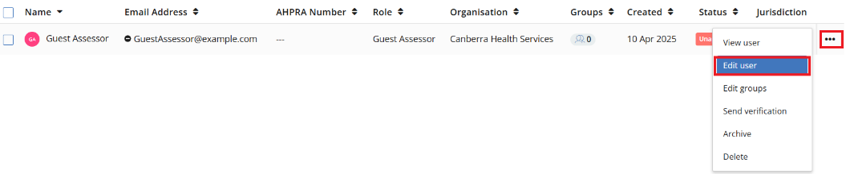
- Change their Status to Approved.
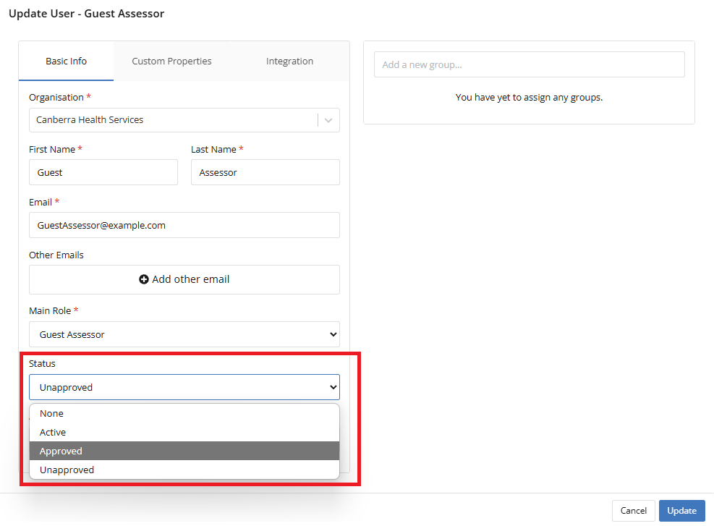
Note: Status is not needed for any other user role types, only for the Guests Assessor role. All other roles default to a Status of None and do not need to be changed.

- If the user is not considered to be a valid assessor, leave their account status as Unapproved and follow up with the prevocational doctor or DCT. Note, forms can be edited or deleted if entered by unauthorised users.

- Modify other details of the user, if necessary, for instance:
  - Name – if entered incorrectly or partially displaying, e.g. Dr Smith
  - Email address – if entered incorrectly
Important – where changing the email address due to incorrect entry, it is recommended to contact the guest assessor to validate that they did complete form(s) for the PGY doctor(s), as the assessor would not have received a confirmation email of having completed forms.
  - Main role – you can change this to Supervisor (Term or Clinical) if the user is a regular and authorised assessor. This will allow them to login to CLA, see PGY doctors that they have completed forms for using this email address because they have been linked to them as a Clinical Supervisor for this term. When changing their role from Guest Assessor to another role, send the user a Verification email from CLA them to activate their account.
  - Jurisdiction (State) for them on the Custom Properties tab and click Update.
See the quick reference guide Creating and Managing Users for more information.

Using Reports to see forms completed by Guest Assessors:
Use the Detailed Response Report or Completion Report by Tags (selecting the Format: Completion Details) to see all forms completed in CLA and these reports will include the name and/or email address of the assessor that completed each form.
Export the CLA reports to Excel and use filters and Excel features to find by name or email address any forms completed by users who are guest assessors for your site.

What happens after a Guest Assessor is approved in CLA?
Users that have a Guest Assessor account will not have access any data if they attempt to activate their account and login to CLA. The approval process simply identifies that they are a verified assessor, and their assessments of the prevocational doctors are accepted.
Once a Guest Assessor has been verified, they can complete assessment forms for any prevocational doctors in the future using the same email address without their submissions being flagged as unapproved.
If the Guest Assessor requires ongoing access to CLA to provide future assessments for one or more prevocational doctors, then the administrator will need to change the ‘Main role’ in their user account to another role type e.g. Supervisor (Term or Clinical) and click ‘Send verification’ to generate a welcome email prompting them to login. They will by default be linked to those prevocational doctors for whom they completed forms as a Guest Assessor previously. To be able to access the ePortfolio for other prevocational doctors, they will need to be linked to those doctors via the Term Allocations process in a PGY Instance (see the Quick Reference Guide Creating and Managing Term Allocations).

Support
If you require any support you can find contact details for the national CLA system administrator as well as relevant state based system administrators on the CLA website.

