Clinical Learning Australia

Training Guide



assessment review panel

This quick reference guide provides information on how the Assessment Review Panel process works within Clinical Learning Australia.

Table of Contents

1 Creating an Assessment Review Panel in CLA 3

1.1 Creating ARP Groups 3

1.2 ARP Roles 5

1.3 If you have multiple roles in CLA 5

2 How does the ARP process work in CLA? 7

2.1 Recording ARP decisions 7

2.2 Certifying Completion 7

2.3 ARP Outcome Form 12

3 Support 13

# Creating an Assessment Review Panel in CLA

An Assessment Review Panel (ARP) is created in CLA by a Medical Education Unit Administrator using the ‘Groups’ functionality. This allows ARP members to be linked to relevant trainees so that they can view their ePortfolio and record decisions related to the overall assessment of their training.

## Creating ARP Groups

You can create an ARP Group in CLA in several ways. You can create a group and add trainees and ARP members manually in the system or via a bulk upload – see the Quick Reference Guide ‘**Creating and Managing Groups’.**

### Replicating Groups

You may want to replicate existing PGY1 / PGY2 groups for the ARP process.

* In this case, first create the groups you wish to use for the ARP.
* Navigate to the cog icon and select ‘Groups’

* Select ‘Create Group’ and complete the Create Group pop-up box will appear
* Enter a group name
* We recommend that you name your ARP group in a similar way to how you have named your PGY instances and clearly identify it as an ARP group:
  + State - Hospital/Program - PGY1/PGY2 - ARP Year
  + E.g. NSW – Nepean Hospital – PGY1 – ARP 2025
* Use the Group Type ‘Group’
* Ensure you add a start and end date to the group; this will ensure that users only have access to trainees in the ARP group for as long as the ARP is active
* Click ‘Create’

* Once you have created the ARP group, navigate to the Users screen and use the filtering to identify all users in your existing PGY1 or PGY2 group that you would like to replicate.

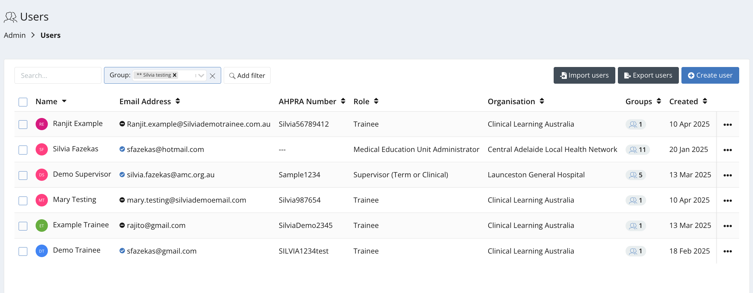

* Select the users you want to add to the ARP group and click ‘Bulk Actions’ and ‘Add Groups

* Type in the name of the ARP group you just created and click ‘Add’

This will add all trainees and other users you have selected to the new ARP group.

## ARP Roles

Within the ARP group, you can assign individuals one of two roles. Both roles will be able to view the ePortfolio of trainees included in the group. These roles are:

* **ARP Lead** – In addition to viewing trainees in the ARP group, this role can add a **proposed and final assessment rating** (see section 2.2)
* **ARP Member** – In addition to viewing trainees in the ARP group, this role will be able to **propose a final assessment** rating (see section 2.2)

There can be multiple ARP Leads and ARP members.

## If you have multiple roles in CLA

If you’re an existing user of CLA and have roles other than an ARP Member or Lead, you will need to switch to your ARP role via the role toggle in the top right-hand corner.

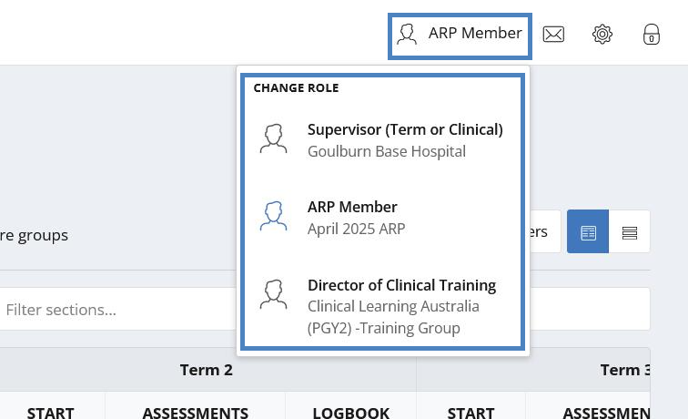

* Navigate to the screen icon in the left-hand menu and click ‘**Trainees’**.

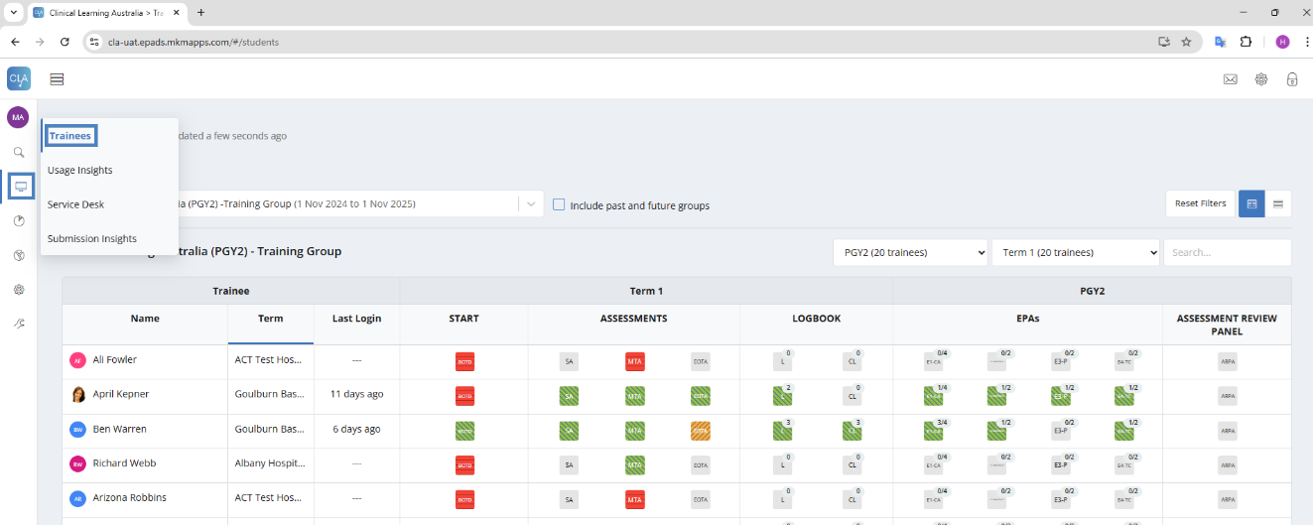

All groups that are linked to you will be available to search for in the left-hand dropdown menu above the dashboard. You can type into this field to locate the group you need to view; this is especially useful if you are a member of multiple groups.

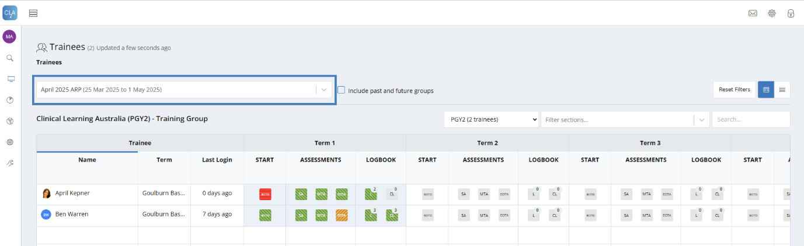

# How does the ARP process work in CLA?

When an ARP group has been established, ARP Leads and ARP members added to that group will be able to view information for all trainees in the group.

There are several components in CLA that an ARP may wish to use to assess whether each trainee has or has not met the requirements to complete their training. These include:

* The trainee dashboard
* Each individual trainee’s ePortfolio (including all completed assessments)
* The Submission Insights Dashboard
* The Detailed Response report

CLA is not prescriptive in terms of how the ARP reviews the trainee’s performance or in the information they consider as this may vary by site.

## Recording ARP decisions

In CLA there are two ways in which the ARP decision can be recorded.

* **Certifying Completion** - This occurs within the Progress Views section of the Trainee’s ePortfolio. It allows ARP Leads and Members to nominate a proposed and outcome to certify PGY completion. This must be completed to finalise a Trainee’s training and generate the transcript of learning.
* **ARP Outcome Form** – This form sits within the Assessment Review Panel tab within the Trainee’s ePortfolio. It is used to record the ARP decision and provide feedback or commentary to the Trainee. Note that information recorded on this form is visible to the trainee. It is optional to complete the ARP outcome form in addition to the final rating and some sites may choose not to.

## Certifying Completion

This step is mandatory and indicates that the Trainee has completed their PGY1 or PGY2 training.

Once you locate the ARP group in the dashboard, you select a Trainee by clicking on their name in the dashboard.

This will then show you that Trainee’s ePortfolio homepage where you can begin the Certifying Completion process.

* Click the Progress View widget

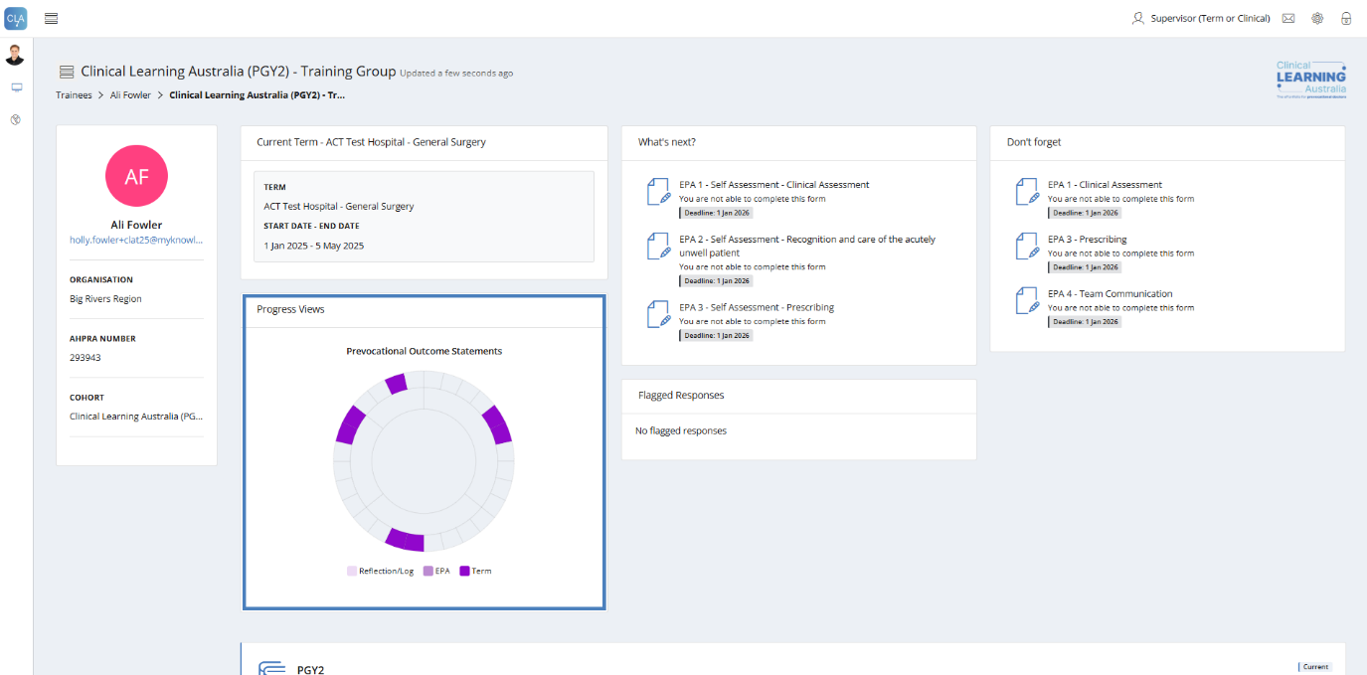

This will open up the progress views window.

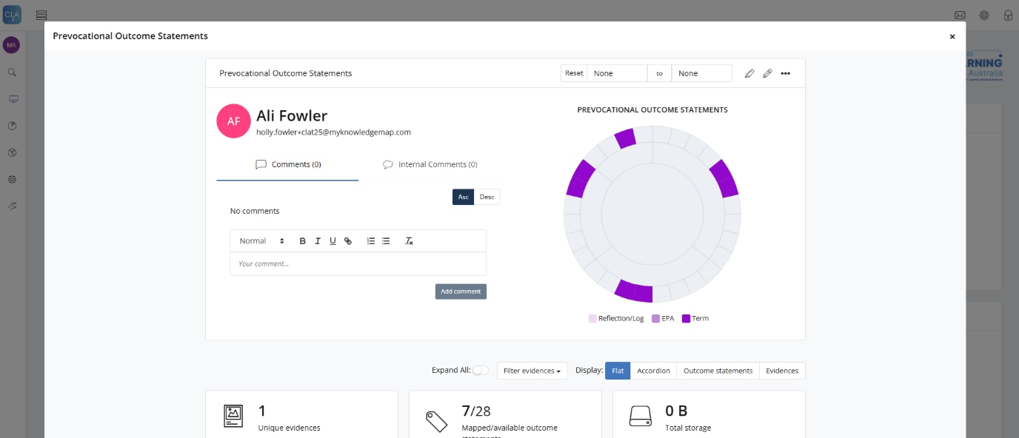

A final ‘rating’ is given to the Trainee as either proposed or applied.



**Propose Rating** – This is an optional step that can be taken if Assessment Review Panel members wish to propose an initial rating for a Trainee which may be later reviewed. A proposed rating is not visible to the Trainee.



**Apply Rating**- When the Assessment Review Panel is ready to certify completion a final rating will be applied by an ARP Lead.

A rating is set by clicking the relevant pencil icon (shown above) and selecting one of the ratings listed in the screenshot.

If a rating has been **proposed**, then that relevant rating will appear under the Trainee’s name within their progress view.

**Note:** This will be **not** visible to the Trainee.

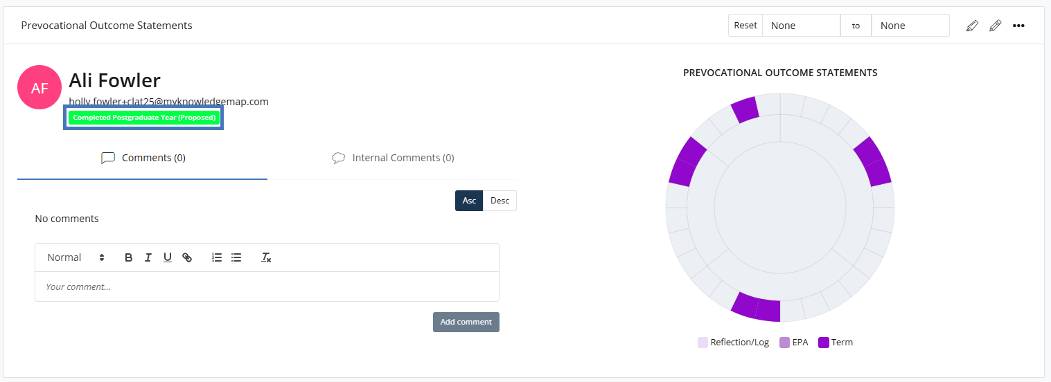

When a **final rating** has been applied the rating appears or is updated under the Trainee’s name and **is visible to the Trainee.**

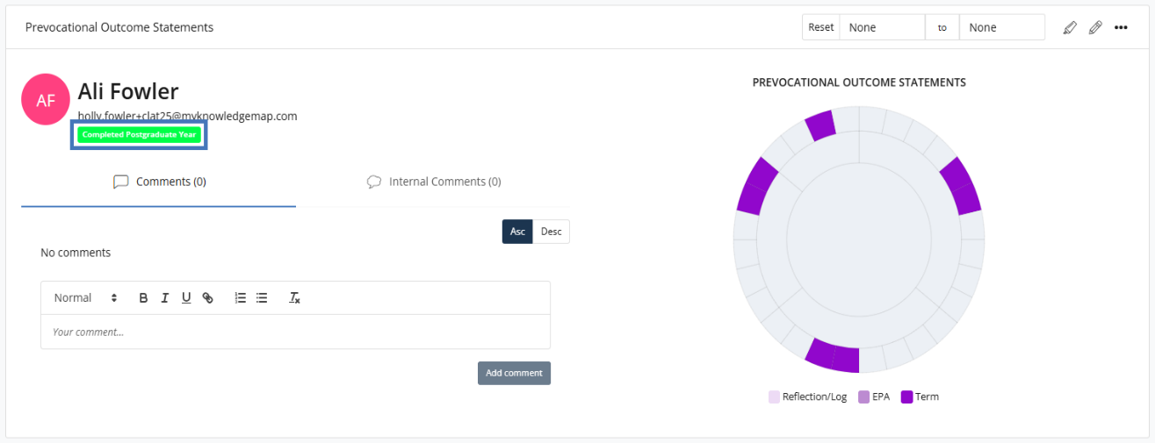

If a grade has been entered as proposed, these can be **accepted**, **rejected**,or **retracted** by an ARP Lead.

You do this by clicking on the rating underneath the trainee’s name in the progress view.

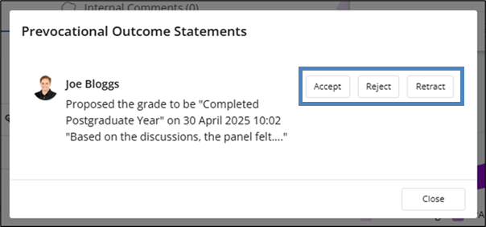

If a final rating has been applied, this can be **retracted** by an ARP Lead.



All members of the ARP can see the history of the proposed and final rating.

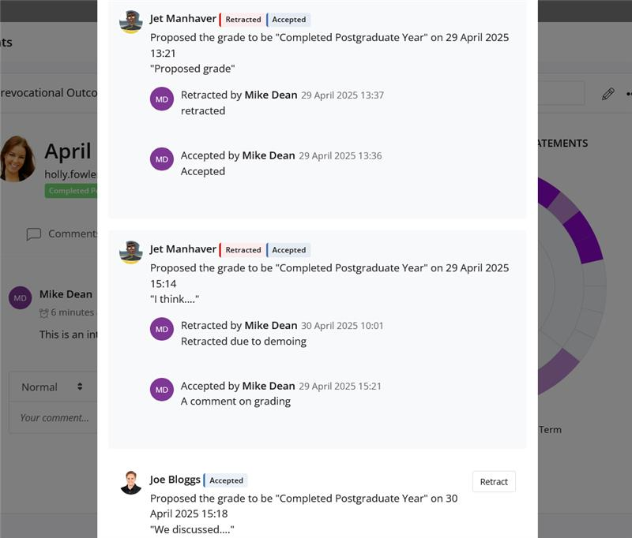

**Adding comments**

Both the ARP Lead and ARP member roles can add comments when they apply a proposed or final rating.

**Important: Comments added to a proposed rating are not visible to the trainee and other users. Comments added to a final rating are visible to the Trainee and other users.**

In addition to comments added when applying a proposed or final rating, there is an ability to add general commentary on the progress views page.

Please note:

* The first ‘Comments’ tab allows a user to add comments that are **visible to the trainee**.
* The second ‘Internal Comments’ field is **visible to all users other than the trainee**.

Please ensure you use the **Internal Comments** field when providing any comments related to ARP discussions.

## ARP Outcome Form

When an ARP decision has been made, an ARP Lead or appropriate administrator can complete the ARP outcome form within the Trainee’s ePortfolio. This step is optional and will depend on how the ARP is managed in each training setting.

Note: The ARP Outcome form **is visible** to Trainees

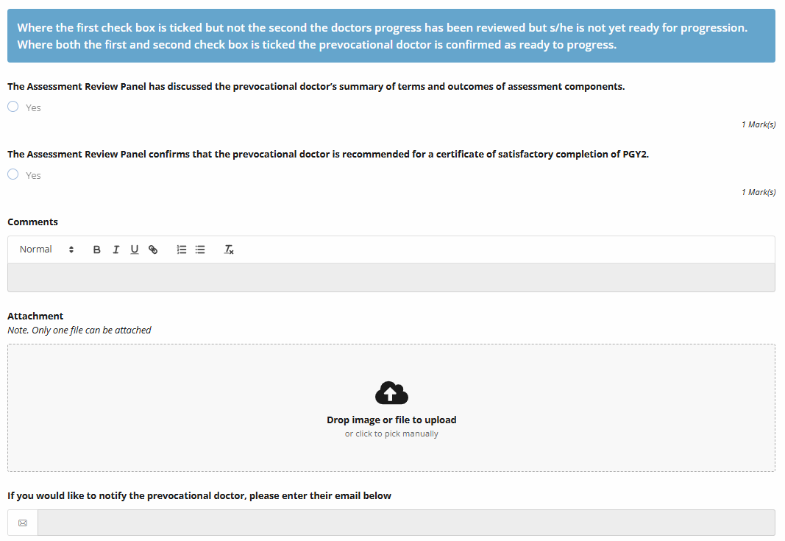

Where the top checkbox has been ticked to indicate that the Trainee’s progress has been discussed, but where the second checkbox confirms that the Trainee’s that they are recommended for certification of completion has not been ticked, the ARP icon on the dashboard will turn amber. Where both tick boxes are checked, the ARP icon on the dashboard will turn green.

ARP Leads or Administrators can add additional commentary or attachments to provide feedback to the Trainee via this form.

# Support

If you require any support please contact the Nationwide Administrator. Contact details can be found on the [CLA website](https://www.digitalhealth.gov.au/healthcare-providers/initiatives-and-programs/workforce-capability/clinical-learning-australia).