Clinical Learning Australia

Training Guide



generating a transcript of learning

This quick reference guide provides information on how to produce a transcript of learning at the end of PGY1 and PGY2 within Clinical Learning Australia.

Table of Contents

1 Producing a Transcript of Learning 3

1.1 Where to produce a transcript of learning 3

1.2 How to produce a transcript of learning 3

2 Support 9

# Producing a Transcript of Learning

Medical Education Unit Administrators within Clinical Learning Australia can produce a Transcript of Learning for Trainees at the end of PGY1 and PGY2. A Transcript of Learning is a formal record of training completed by the prevocational doctor.

Generation of a Transcript of Learning is done once the Assessment Review Panel has convened and certification of completion has been finalised. Once the transcript of learning has been generated, any relevant roles within the system can then download this for trainees they have access to.

## Where to produce a Transcript of Learning

A Transcript of Learning is produced within a Trainee’s ePortfolio.

* Navigate to the screen icon in the left-hand menu and click ‘**Trainees’**.
* Click on the Trainee you want to produce a transcript of learning for.

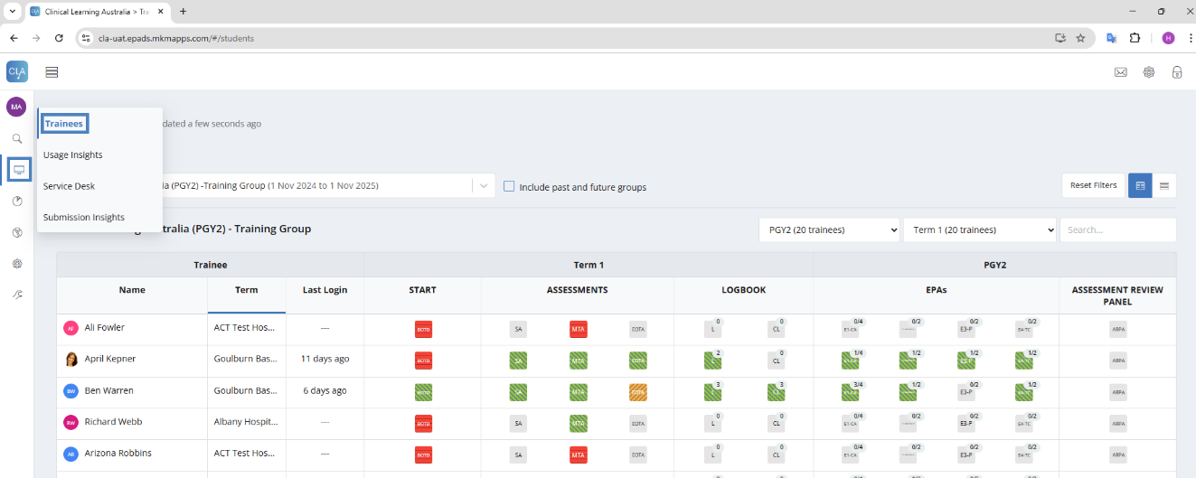

## How to produce a transcript of learning

Once you are within the Trainee’s ePortfolio that you want to produce a Transcript of Learning for, you click on the ‘Progress Views’ widget.

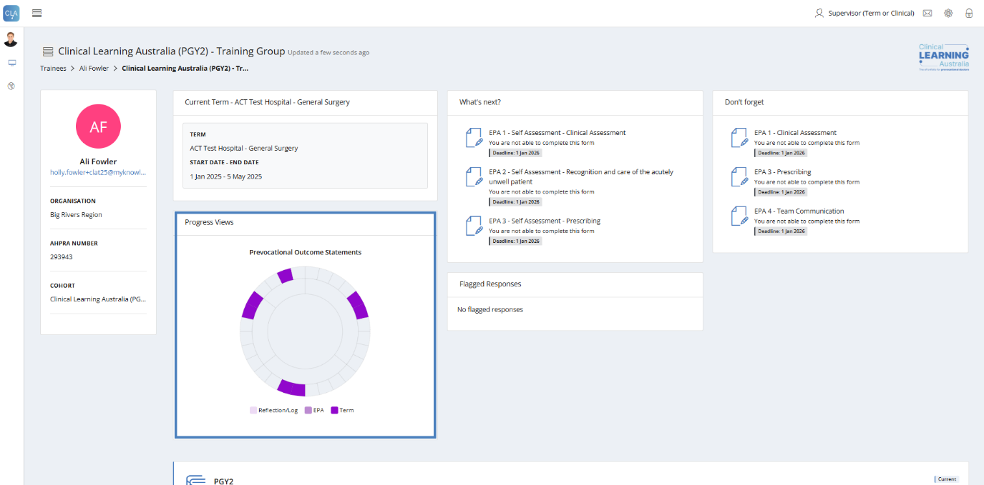

The Progress Views window will appear.

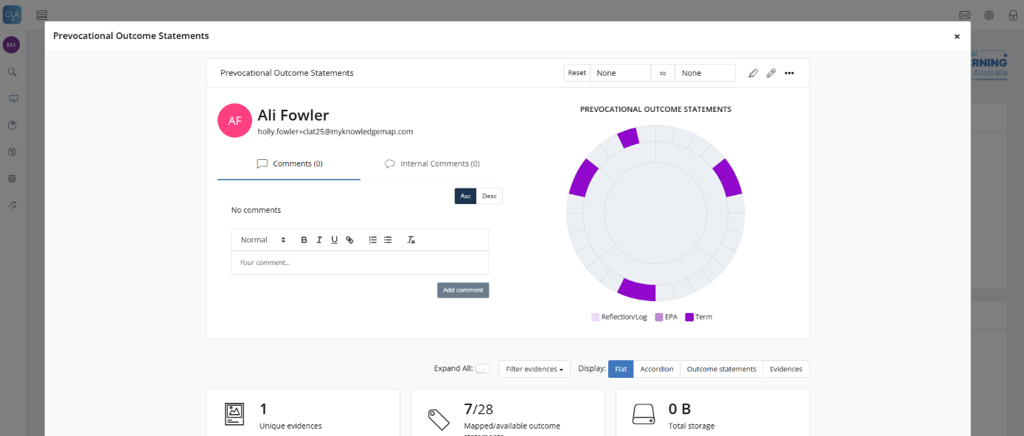

* Click on the three dots ‘**…**’ to the right-hand side of the screen
* Click ‘Mark as complete’

**Note:** If you need to undo this, you can do so by following the same steps as above and instead clicking ‘**Mark as not complete**’.

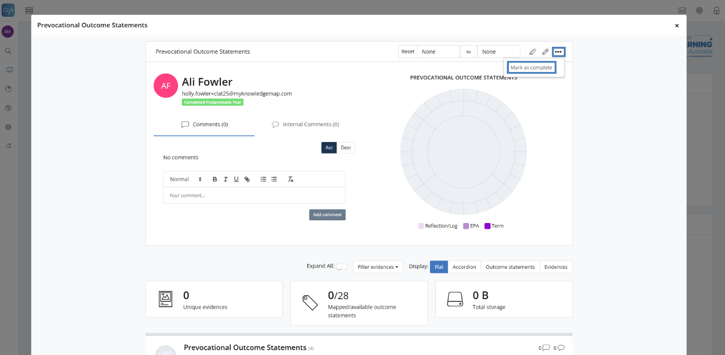

A blue bar will appear stating ‘This progress view has been marked as complete on DD MM YYYY HH:MM. No further changes can be made’.

**Note:** Once marked as complete, the trainee and other users linked to that trainee will no longer be able to complete and submit assessments for that trainee.

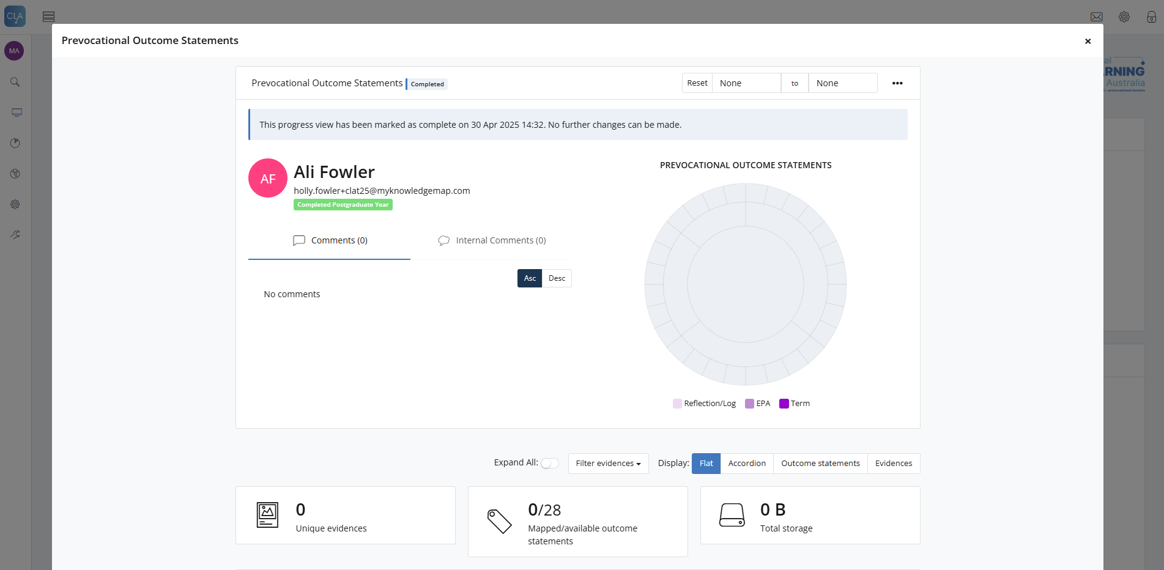

* Click the three dots ‘**…**’
* Click ‘Generate an exportable file’

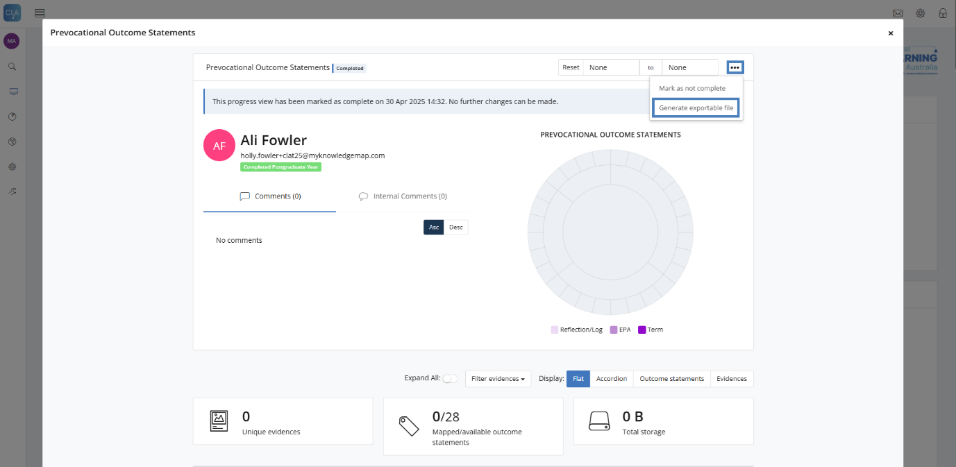

A pop-up window will appear.

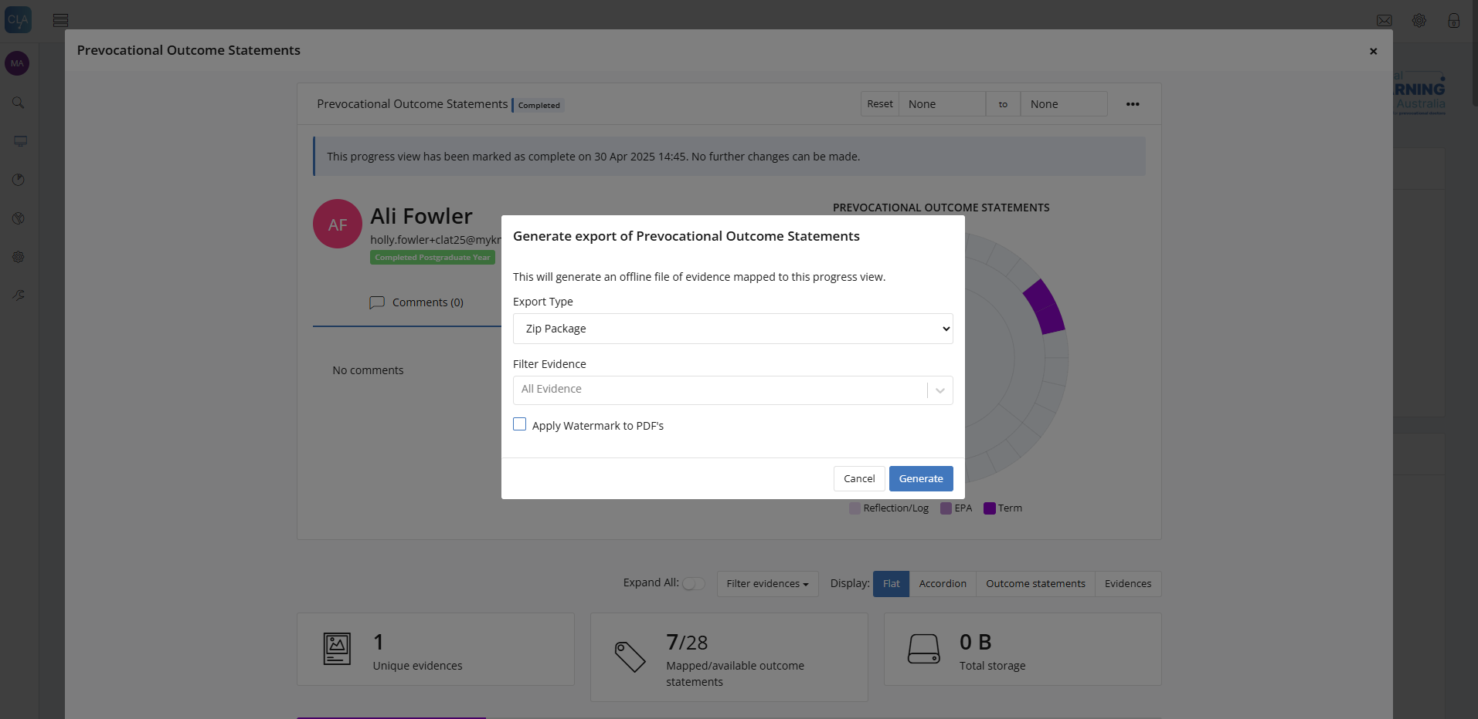

* Select ‘Export Type’ – **PDF**
* Select ‘Filter Evidence’ – **Term**
* Click ‘**Apply Watermark to PDF’s**’
* Click ‘**Generate**’

Note that in the Filter Evidence field you can choose to include End of Term Assessments (Term), EPAs (EPA) and Logbook/Case Procedure entries (Reflection/Log). It is recommended that as a minimum you include Term in this field.

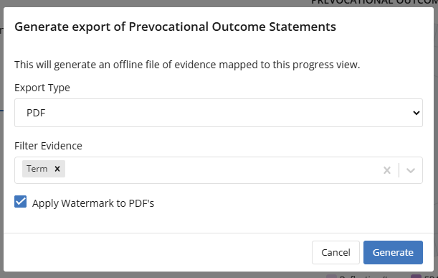

A grey bar will appear stating ‘Generating... Progress view evidence export triggered on DD MM YYYY HH:MM. This can take a while. Please wait or check back later.

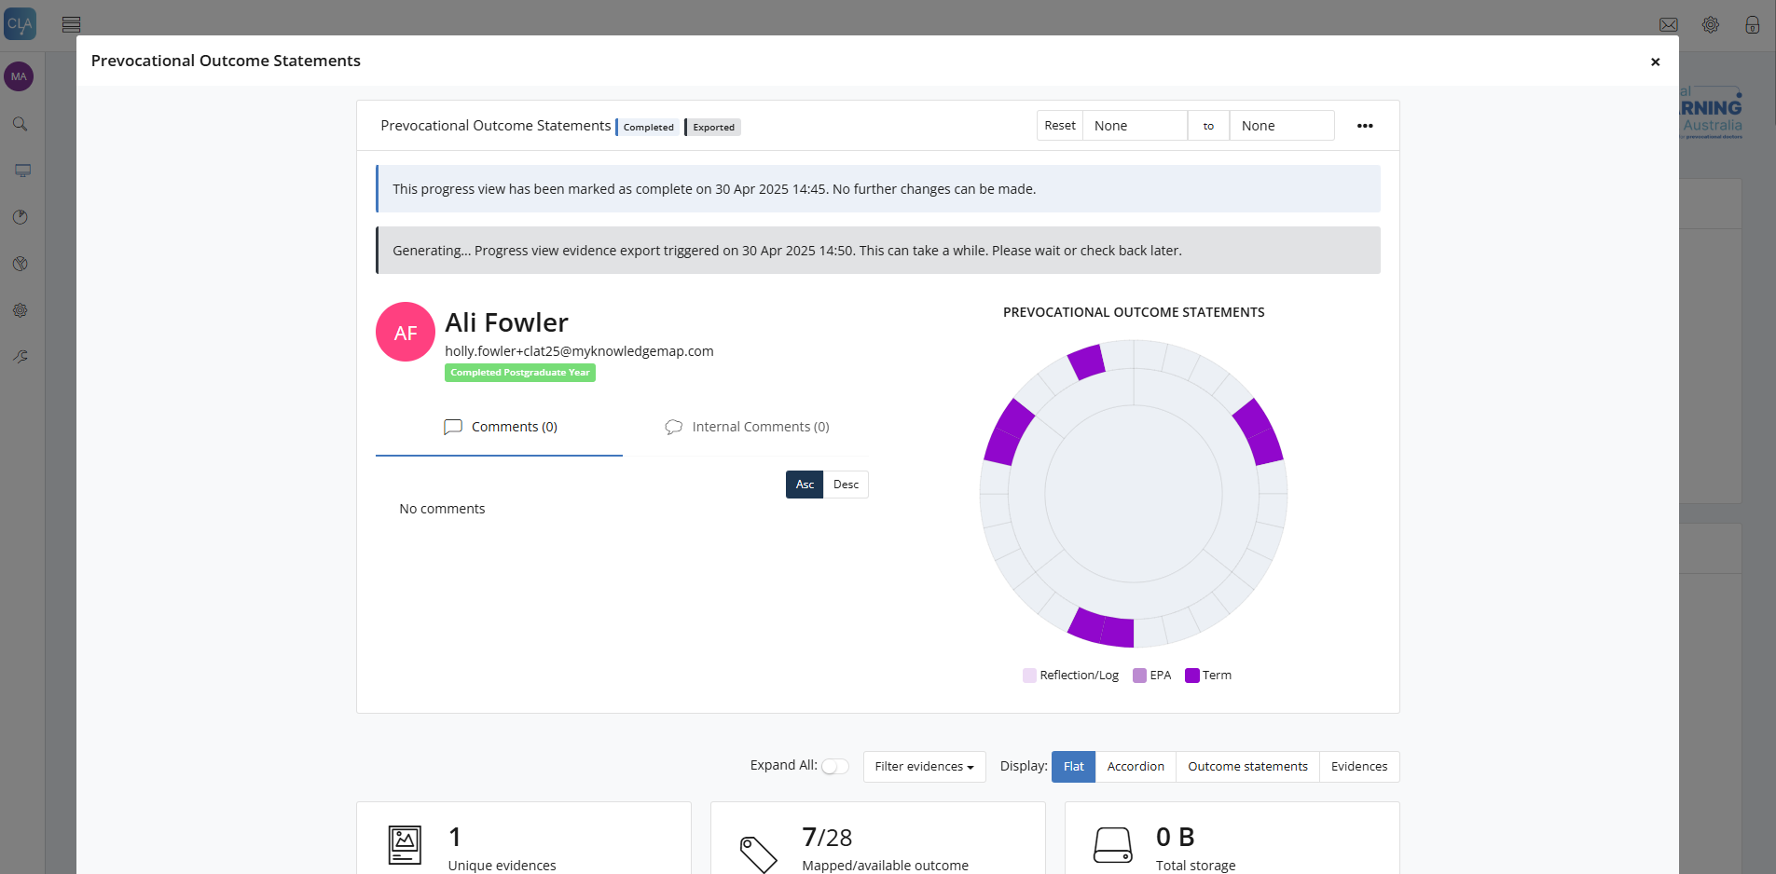

**Note:** As this can take some time to generate, you can leave this screen and continue generating other Trainee Transcripts of Learning, coming back later to then download these Transcripts of Learning, should that be required.

Once the Transcript of Learning is ready to download, a ‘**Download**’ button will appear for relevant users to download the Transcript of Learning for a Trainee.

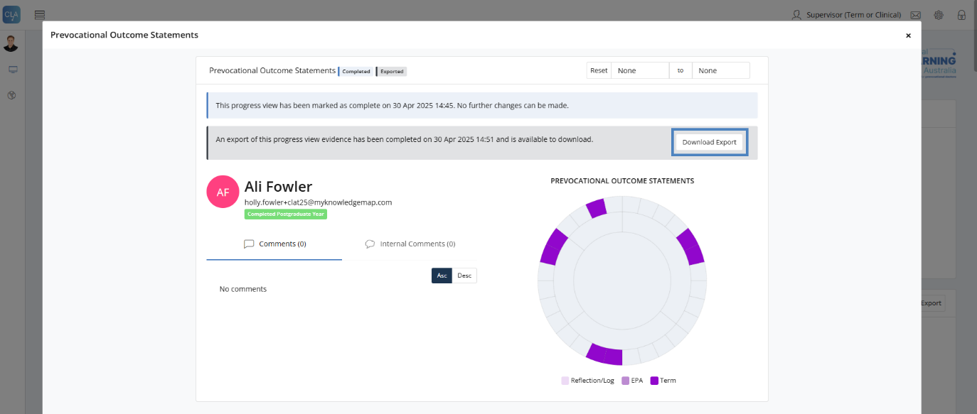

It will also be able to be downloadable on the progress views widget on a Trainee homepage.

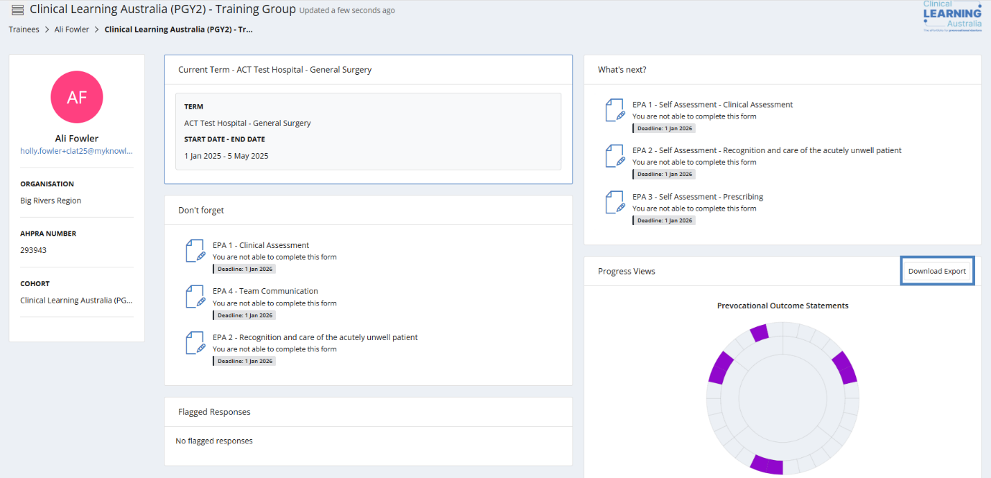

The file will go into your downloads on your desktop, tablet or mobile device.

An example export of a Transcript of Learning.

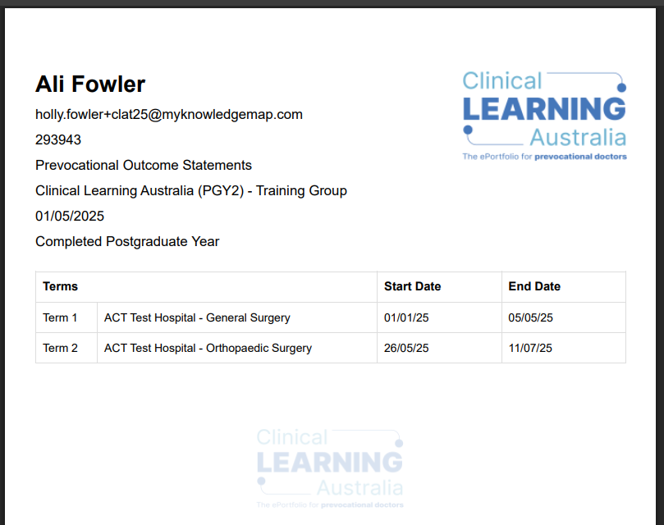

# Support

If you require any support please contact the Nationwide Administrator. Contact details can be found on the [CLA website](https://www.digitalhealth.gov.au/healthcare-providers/initiatives-and-programs/workforce-capability/clinical-learning-australia).